

**TRENDS**

**Developed By:**

**Tatva Shah : 205170686002**

**Umang Patel : 205180696047**

**Aryan panchal : 205170686026**

**Group No : IMCA_9_G10**

**Under the Guidance of : Pratvi ma’am**

**Submitted To :**

**L.J. Institute of Computer Application**

**L.J. INSTITUTE OF ENGINEERING & TECHNOLOGY**

Near Nagdev Kalyan Mandir, Near Sarkhej Cross Roads,

Sarkhej-Gandhinagar Highway  Ahmedabad - 382210  
Ph. No. : 079 29296364



***CERTIFICATE***

**Enrollment No**: **205170686002**

This is to certify that Mr. / Ms. **Tatva Shah** studying in Integrated Master of Computer Applications, Semester IX, Roll No **ICA-49** has satisfactorily completed his/her Project Titled **Trends**  under the supervision of **Prof. Pratvi ma’am**

**Internal Guide Name :** **Signature**

Prof. Pratvi ma’am

**Date of Submission:**

**Director**

**Prof. Aalok Manke**

**L.J. INSTITUTE OF ENGINEERING & TECHNOLOGY**

Near Nagdev Kalyan Mandir, Near Sarkhej Cross Roads,

Sarkhej-Gandhinagar Highway  Ahmedabad - 382210  
Ph. No. : 079 29296364



***CERTIFICATE***

**Enrollment No**: **205180696047**

This is to certify that Mr. / Ms. **Umang Patel** studying in Integrated Master of Computer Applications, Semester IX, Roll No **IET- 42** has satisfactorily completed his/her Project Titled **Trends** under the supervision of **Prof. Pratvi ma’am**

**Internal Guide Name:** **Signature**

Prof. Pratvi ma’am

**Date of Submission:**

**Director**

**Prof. Aalok Manke**

**L.J. INSTITUTE OF ENGINEERING & TECHNOLOGY**

Near Nagdev Kalyan Mandir, Near Sarkhej Cross Roads,

Sarkhej-Gandhinagar Highway  Ahmedabad - 382210  
Ph. No. : 079 29296364



***CERTIFICATE***

**Enrollment No**: **205170686026**

This is to certify that Mr. / Ms. **Aryan Panchal** studying in Integrated Master of Computer Applications, Semester IX, Roll No **ICA-19** has satisfactorily completed his/her Project Titled **Trends**  under the supervision of **Prof. Pratvi ma’am**

**Internal Guide Name :** **Signature**

Prof. Pratvi ma’am

**Date of Submission:**

**Director**

**Prof. Aalok Manke**

**Acknowledgement**

It is our privilege to express our sincerest regards to our faculty and project guide, **Prof. Pratvi ma’am** for their valuable inputs, able guidance, encouragement, whole-hearted cooperation and constructive criticism throughout the duration of our project. We deeply express our sincere thanks to our Head of Director **Dr. Monica Gahlawat** for encouraging and allowing us to present the project on the topic “**Trends**” at our department premises for the partial fulfilment of the requirements leading to the award of Integrated Master of Computer Application (IMCA) degree. We take this opportunity to thank all our lecturers who have directly or indirectly helped our project. Last but not the least we express our thanks to our friends for their cooperation and support.

Table of Contents

1. INTRODUCTION 8

1.1 EXISTING SYSTEM 10

1.2 NEED FOR THE NEW SYSTEM 11

1.3 OBJECTIVES OF THE NEW SYSTEM 12

1.4 PROBLEM DEFINITION 13

1.5 CORE COMPONENTS 14

❖ User Module 14

❖ Admin Module 14

1.6 PROJECT PROFILE 15

1.7 ASSUMPTIONS AND CONSTRAINTS 16

1.8 ADVANTAGE AND LIMITATIONS OF THE PROPOSED SYSTEM 17

❖ Advantages 17

❖ Disadvantages 18

2. REQUIRMENT DETERMINATION AND ANALYSIS 19

2.1 Requirement Determination: 19

2.2 TARGETED USERS 20

3. SYSTEM DESIGN 21

3.1 Use case Diagram: 21

3.2 Class Diagram: 23

3.3 Interaction Diagram 24

❖ Admin Add products: 24

❖ Admin Update Product: 25

❖ Admin Delete Product: 26

❖ Customer Add Product to Cart: 27

❖ Customer Delete Products from Cart : 28

3.4 Activity Diagram 29

❖ Admin Manage Product: 29

❖ Customer Add Products to Cart: 30

❖ Customer Place Order: 31

3.5 Data Dictionary: 32

❖ **Table Name:** Registration 32

❖ **Table Name:** Category 32

❖ **Table Name:** Sub- category 33

❖ **Table Name:** Order 33

❖ **Table Name:** Products 33

❖ **Table Name:** Cart 34

❖ **Table Name:** Payment 34

4. Development 35

4.1 Coding Standards 35

❖ Coding Style 35

❖ Formatting 35

❖ Commenting 35

4.2 Screen Shots 36

❖ Admin 36

❖ Customer 46

5. Agile Documentation 55

5.1 Agile Project Charter: 55

5.2 Agile Roadmap / Schedule 56

5.3 Agile Project Plan 57

5.4 Agile User Story 59

5.5 Agile Release Plan 60

5.6 Agile Sprint Backlog 61

5.7 Agile Test Plan 62

5.8 Earned-value and burn charts 67

6. Proposed Enhancements 68

6.1 Proposed Enhancements 68

7. Conclusion 70

7.1 Conclusion 70

8. Bibliography 71

8.1 Site References : 71

# INTRODUCTION

* Online shopping is a form of E-commerce which allows consumers to directly buy goods or services from the Internet using a web browser or a mobile app. Consumers find a product of interest by visiting the website of the retailer directly or by searching among alternative vendors using a shopping search engine, which displays the same product's availability and pricing at different e-retailers. As of 2024, customers can shop online using a range of different computers and devices, including desktop computers, laptops, tablet computers and smartphones.
* Online customers must have access to the Internet and a valid method of payment in order to complete a transaction, such as a credit card, or a service such as PayPal. For physical products (e.g., paperback books or clothing). An online store may also be called an e-web-store, e-shop, e-store, Internet shop, web-shop, web-store, online store, online storefront and virtual store. Online stores are usually available 24 hours a day.
* In the present scenario, the biggest market for this (online shopping) business is by highly educated people, mostly. This system has been designed keeping in mind all the aspects such as loading the data, complexity, and maintaining the security of user credentials. Here in this system, complexity refers to the total number of features being provided to users, and their smooth arrangement and functioning required.
* Our clothing store is the base on the customer can easy to buy product in the online website. We provide the online payment system in our website For easy to buy product. The system would be easy to use and hence make the shopping experience pleasant for the users.
* People in large number are doing online shopping today, and it is not only because it is convenient as one can shop from home, but also because there is an number of varieties available, with a high competition of prices, and also it is easy to navigate for searching regarding any particular item.

## EXISTING SYSTEM

* The present scenario for shopping is to visit the shops and market manually and then from the available product list one needs to choose the item h e or she wants and then pay for the same item mainly in cash mode is done, as not every society is well educated and aware to use net banking or card modes or wallets etc.
* Also, not really good markets exist everywhere, so many times good markets become out of reach for certain people.
* In the proposed system customers need not go to the shops for purchasing the products.

## NEED FOR THE NEW SYSTEM

* There are large numbers of commercial Online Shopping websites offering large number of products tailored to meet the shopping interests of large number of customers. These online marketplaces have thousands of products listed under various categories.
* **Convenience:** This is the one of the main reasons that online shopping become so popular, as it allows you to switch stores and products by clicking a button rather than traveling to a new store.
* **No crowds:** You hate crowds when you're shopping. Especially during festivals or special events, they can be such a huge headache. Grumpy, annoying, and smelly people also annoy me when I'm out shopping. Plus, parking becomes a huge issue. Al of these problems can be avoided when you "shop online".
* **No need to travel:** People don't usually like to move a lot to get what they want. Of course, nothing can compete with experience of going to a cloth boutique and buying what you want, but normally people just don't want to travel.

## OBJECTIVES OF THE NEW SYSTEM

* The objective of this system is to provide easy assistance to both the customer as well as the merchant with proper database and information.
* The purpose of online clothing store is to save time, save money. Through online clothing store one can save his valuable time. One can watch and select thing he wants buy. Through online clothing store we can save over money because prices are less then market prices and we receive our bought things at home. No need to go anywhere and do shopping. We can get different varieties of things online and we can choose which one we want.

## PROBLEM DEFINITION

* There are expenses for traveling from house to shop. More over the shop from where we would like buy something may not open 24*7. In order to overcome these, we have online clothing store solution. i.e. One place where we can get all required products online.

## CORE COMPONENTS

### User Module

* Allow to user Sign Up
* Allow to user Login page
* Allow to user Shop view
* Allow to user Cart view
* Allow to user Payment Get way
* Allow to user Order view
* Allow to user Logout

### Admin Module

* Allow to Admin Login
* Allow to Admin Manage customer
* Allow to Admin Manage order
* Allow to Admin Manage product
* Allow to Admin Change password
* Allow to Admin logout

## PROJECT PROFILE

|  |  |
| --- | --- |
| Project Title | Trends |
| Components/Modules | Admin  User |
| Institute Name | L.J. Institute of Computer Applications |
| Duration | 3 months |
| Project Internal Guide | Prof. Pratvi ma’am |
| Software used   * Framework * Backend | Laravel  MySQL, PHP |
| Operating System | Macbook M1Chip |
| Team Members | * **Tatva Shah ICA-49** * **Umang Patel IET-42** * **Aryan Panchal ICA-19** |

## ASSUMPTIONS AND CONSTRAINTS

* This project can be modified in future according to the need of Customer and administrator.

## ADVANTAGE AND LIMITATIONS OF THE PROPOSED SYSTEM

### Advantages

* **Shop From Any Location: -**

Online shopping gives you the freedom to choose where you want to shop. You could be lounging on your couch, or even be on your lunch break at work, and you can still shop for "clothing online". This way, you don't have to worry about going anywhere just to go shopping.

* **Time to Convenience:-**

Online shopping allows you to save a lot of time and energy. It makes it easier to find the items you want, as you have access to endless brands and online stores from your computer or smartphone.

* **A Greater Variety of choices: -**

Shopping for "clothing online" exposes you to a variety of shopping options to choose from. You are no longer limited to the options provided by the physical stores near you.

* **Shop Internationally: -**

Online shopping exposes you t o a global platform. You are no longer limited to your location when shopping for clothing you can purchase items from your favorite brand at any time and from any place.

* **No Crowds: -**

Shopping for "clothing online" allows you to enjoy privacy while you shop. You don't have to experience the discomfort of being in a crowded store, and you won't have to wait in long queues.

### **Disadvantages**

* **Delay in the delivery: -**

**In case of offline shopping, you can receive the product then and there. But, this does not happen in online shopping.**

* **You can't touch the product: -**

**The sad part of online shopping is, you cannot touch the product and feel how it is.**

* **You cannot bargain:-**

**Indians are good at bargaining. You can bargain only in case of offline shopping, not in the case of online shopping.**

# REQUIRMENT DETERMINATION AND ANALYSIS

## Requirement Determination:

* Gathering requirements for a user-friendly interface, secure payment gateway, efficient inventory management system, and responsive customer support.
* **Functional Requirement:**

**Hardware Requirement**

* Processor: macOS m1 chip
* RAM: 8GB
* Hard Disk: 256GB

**Software Requirement**

* Operating System: Windows
* Front-end: Visual Studio code
* Back-end: MY SQL
* **Non-Functional Requirement:**
* **Reliability Requirement:** Our system will provide a reliable environment to both user and admin. All orders should be reaching at the admin without any errors.
* **Usability Requirement:** This system is designed for user friendly environment and ease of use.
* **Security:** This system must automatically logged out after all customers inactivity for long duration. The system backend database accessible by only specific administrator.

## TARGETED USERS

* any visitor can go through our website and get information about the cloth.
* The User can search the clothes by brands.
* But if they want to place order or add product to cart/purchase then they must have to register and then login.

# SYSTEM DESIGN

## 3.1 Use case Diagram:

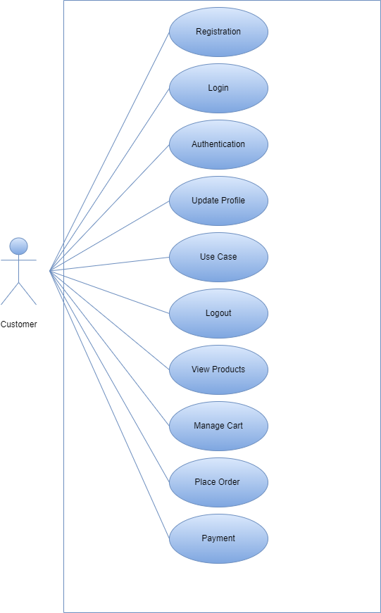

Use Case Diagram : Admin

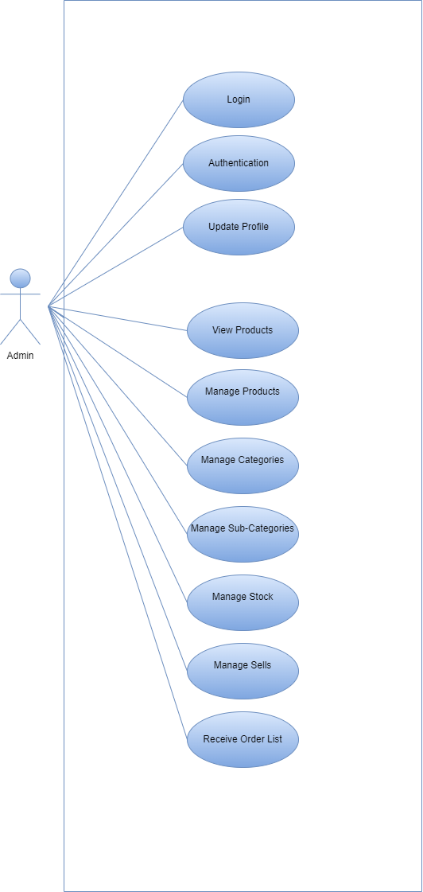

## 3.2 Class Diagram:

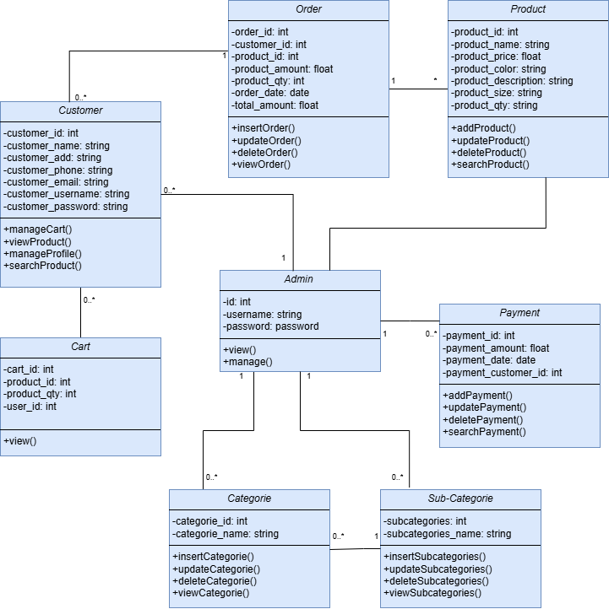

## 3.3 Interaction Diagram

### Admin Add products:

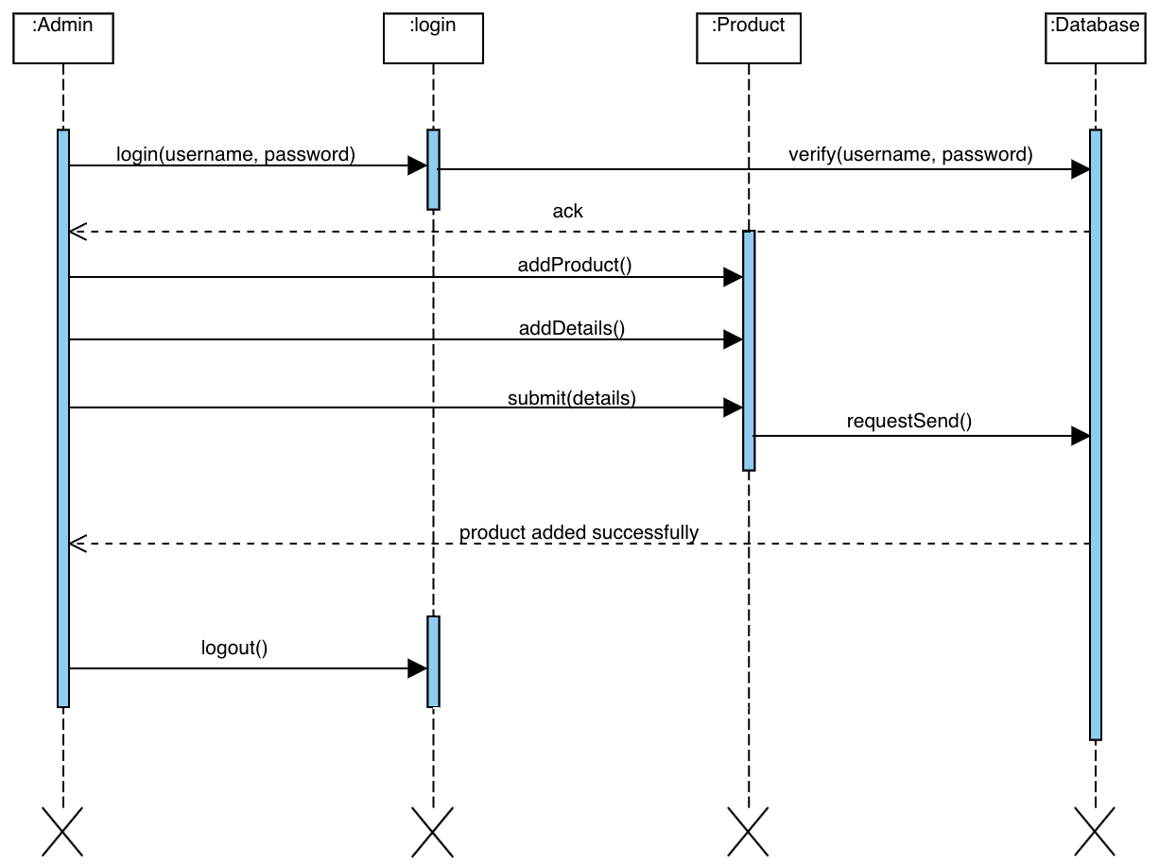

### Admin Update Product:

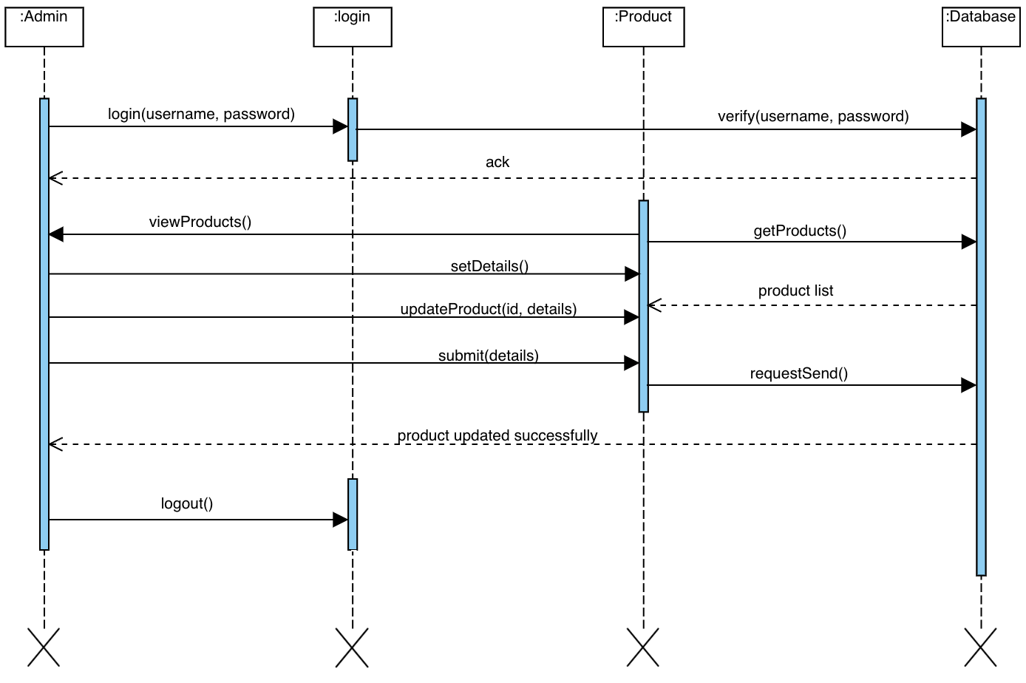

### Admin Delete Product:

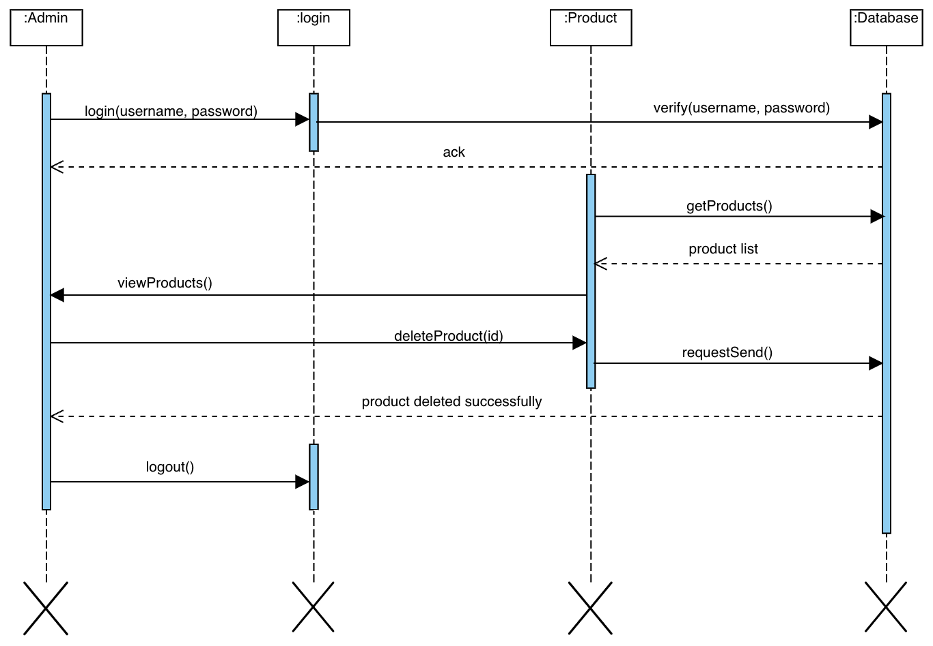

### Customer Add Product to Cart:

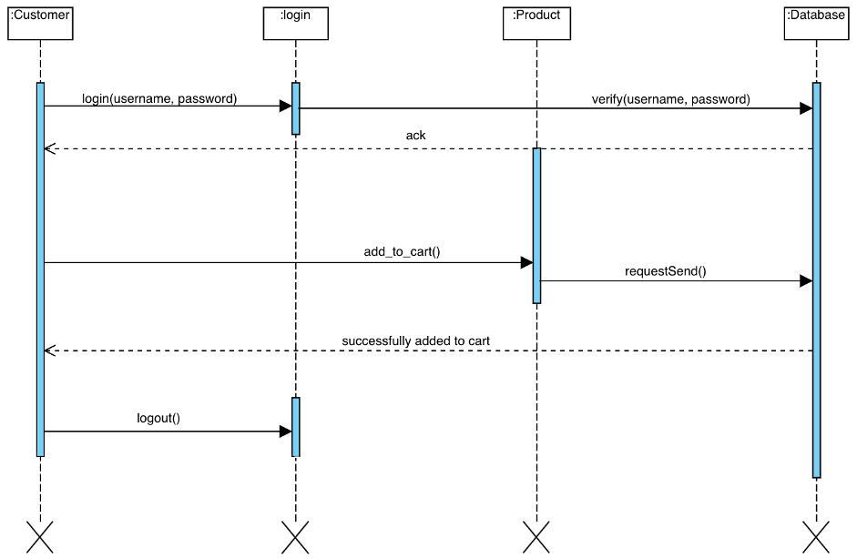

### Customer Delete Products from Cart :

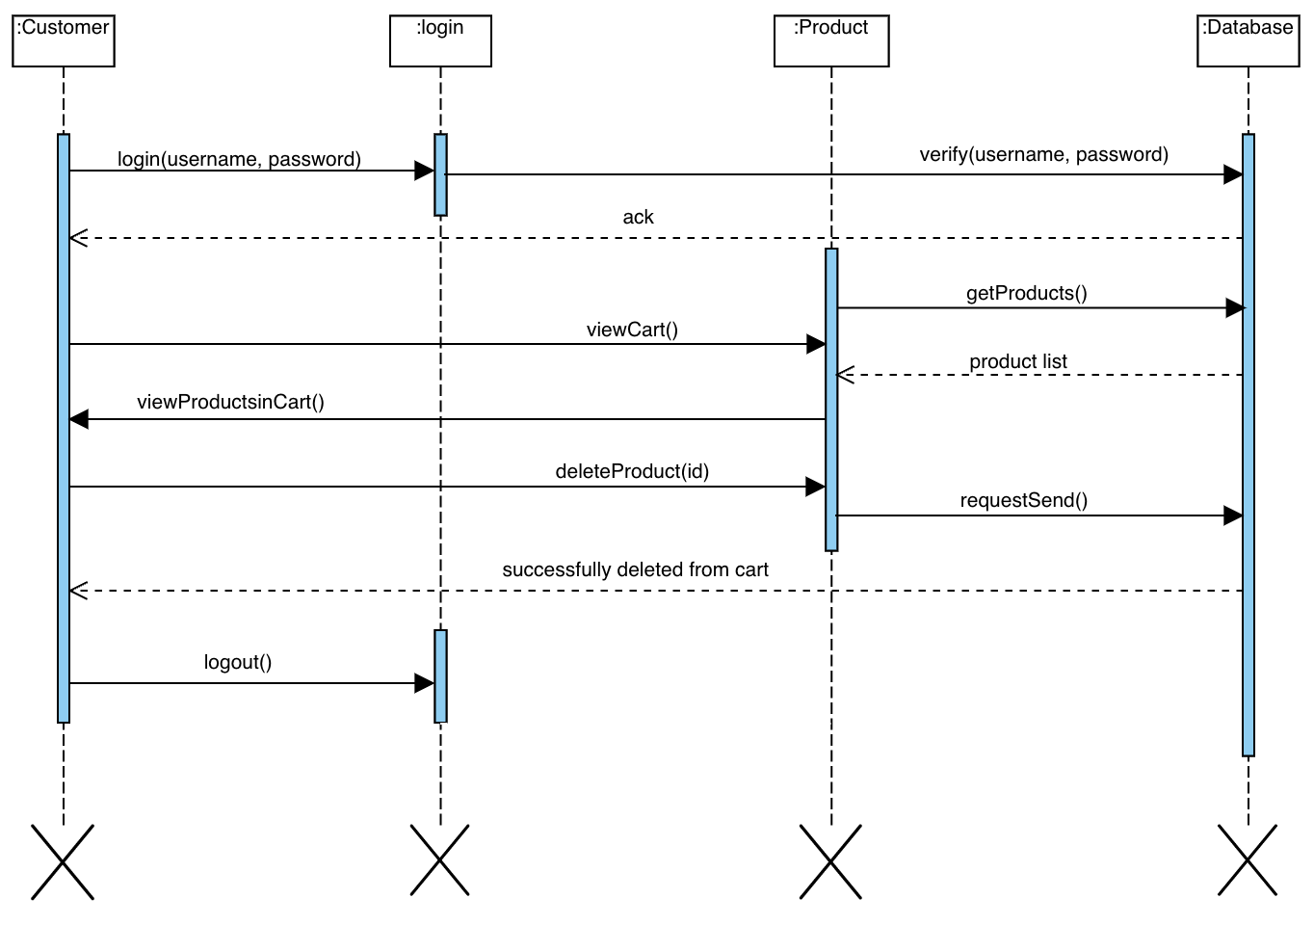

## 3.4 Activity Diagram

### Admin Manage Product:

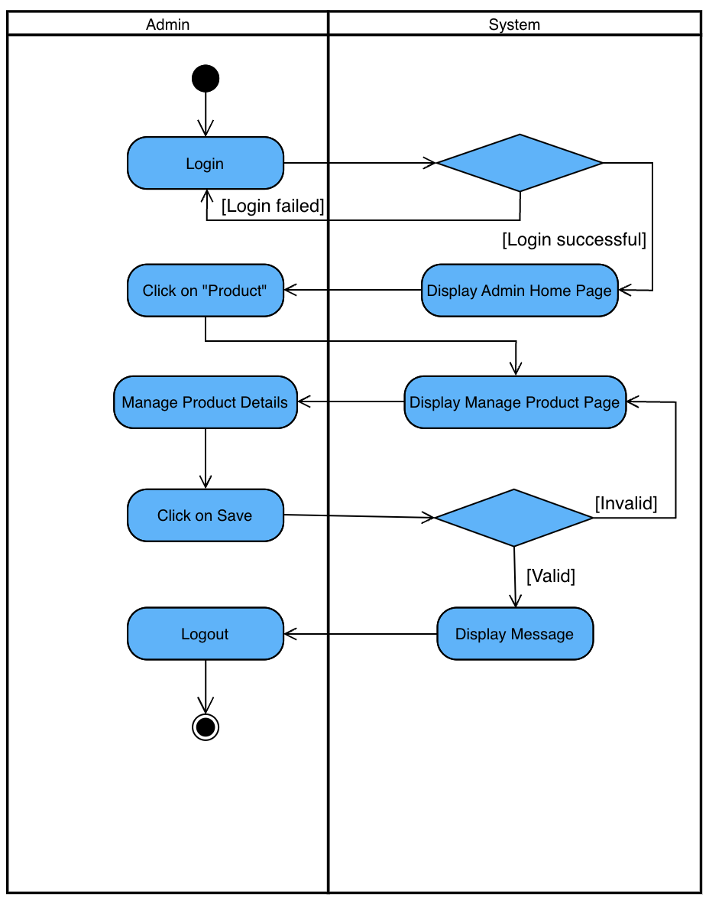

### Customer Add Products to Cart:

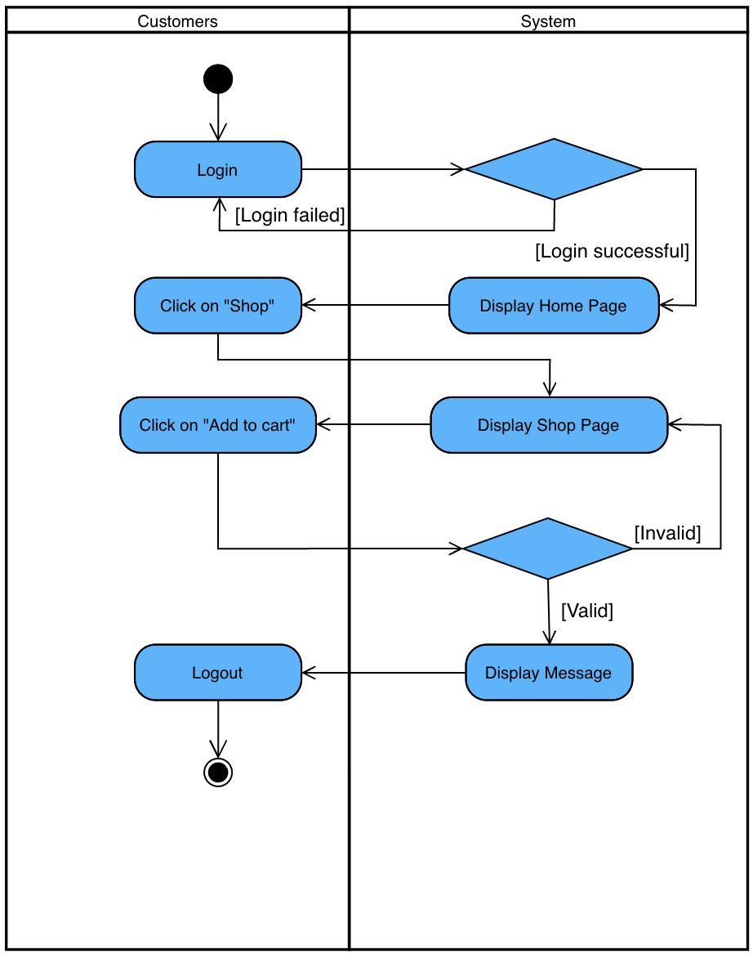

### Customer Place Order:

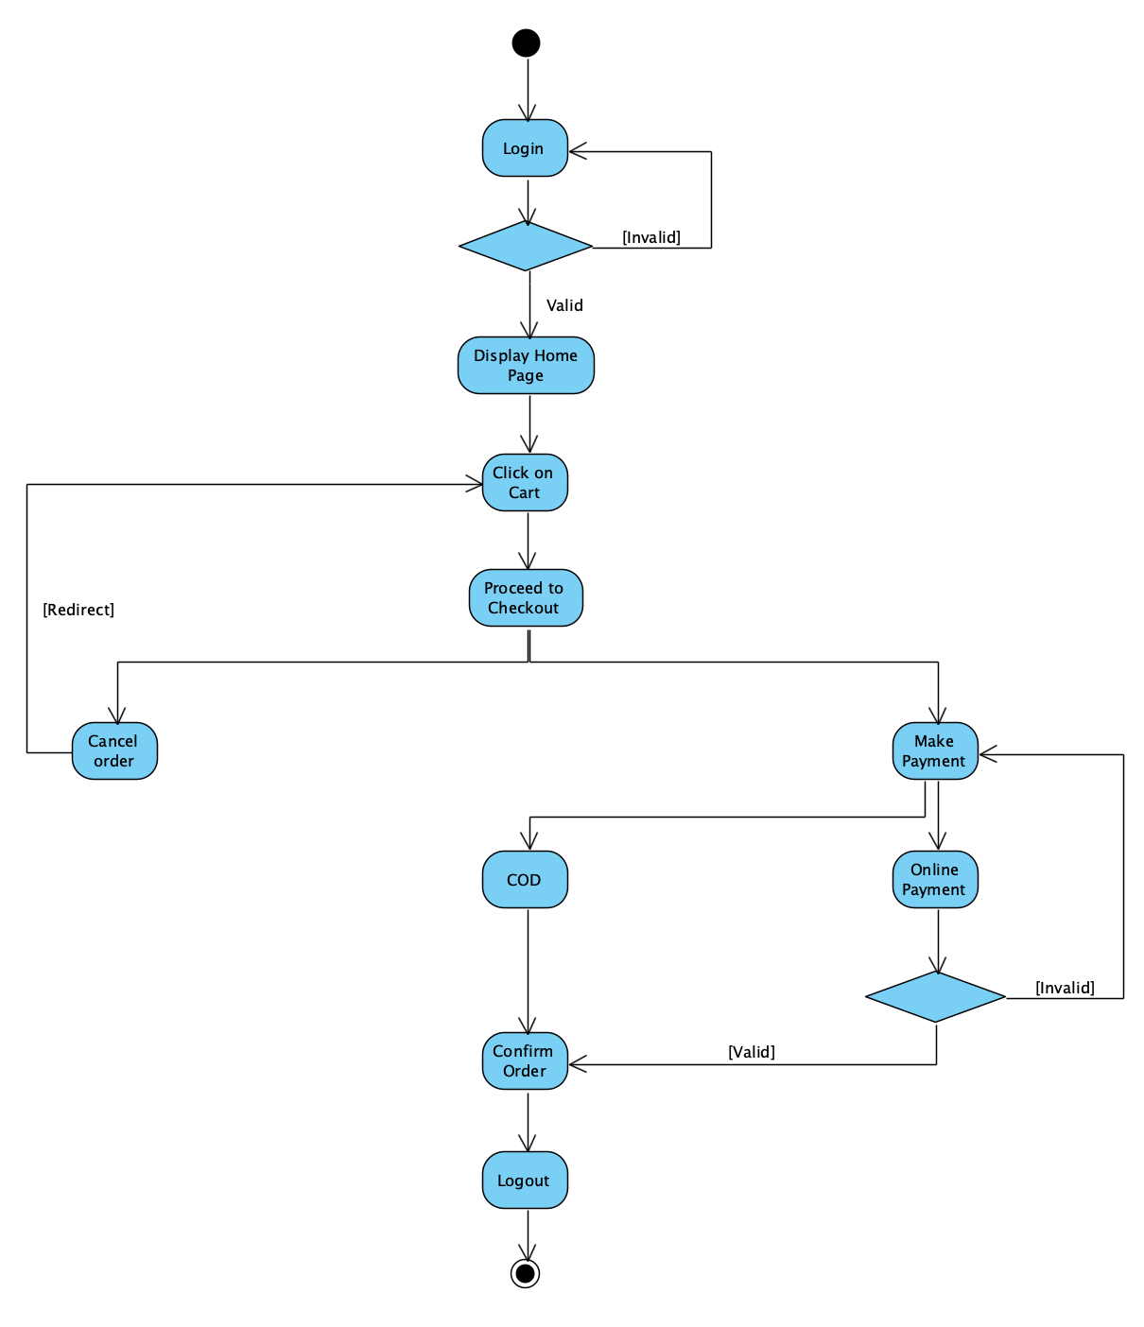

## **3.5 Data Dictionary:**

### **Table Name:** Registration

|  |  |  |  |  |  |
| --- | --- | --- | --- | --- | --- |
| Field | Type | Size | Constraint | Description | Example |
| User_id | Int | 11 | Primary key | Id of user | 1 |
| F_name | Varchar | 50 | - | First Name of user | Umang |
| L_name | Varchar | 30 | - | Last Name of user | Patel |
| Email | Varchar | 20 | Unique key | Email-id of user | abc@gmail.com |
| Username | Varchar | 20 | Unique key | Username | Abcd |
| Password | Varchar | 15 | - | Password | 1234 |
| Phone no | int | 10 | Unique key | Phone no | 1234567890 |
| address | varchar | 50 | - | Address | 1,ahmedabad |

### **Table Name:** Category

|  |  |  |  |  |  |
| --- | --- | --- | --- | --- | --- |
| Field | Type | Size | Constraint | Description | Example |
| Category_id | int | 20 | - | category | 1 |
| Category_name | Varchar | 20 | Unique key | Category name | External Kids, Men, Women, accessories |

### **Table Name:** Sub- category

|  |  |  |  |  |  |
| --- | --- | --- | --- | --- | --- |
| Field | Type | Size | Constraint | Description | Example |
| Sub-category_id | int | 10 | - | Sub-category | 1 |
| Sub-category_name | Varchar | 20 | Unique key | Sub-category name | Different type of clothing |

### **Table Name:** Order

|  |  |  |  |  |  |
| --- | --- | --- | --- | --- | --- |
| Field | Type | Size | Constraint | Description | Example |
| Order_id | Int | 15 | Primary Key | Id of Order | 7996 |
| Order_date | Date | - | Date | Date of Order | 29-02-2024 |
| Customer_id | Varchar | 15 | - | Name of Customer | Tatva |
| Cart_id | Varchar | 20 | - | Product name | Men T-shirt |

### **Table Name:** Products

|  |  |  |  |  |  |
| --- | --- | --- | --- | --- | --- |
| Fields | Type | Size | Constrain | Description | Example |
| Product_id | Int | 12 | Primary key | Unique id | 12345678902 |
| Product_name | Varchar | 25 | Foreign key | Name of product | Adidas, PUMA, ZARA etc. |
| Product_price | int | 10 | - | Price of product | 5000 |
| Product_description | char | 50 | Foreign key | Product  description | information |
| Product_image | image | 6 | - | Product image | image |

### **Table Name:** Cart

|  |  |  |  |  |  |
| --- | --- | --- | --- | --- | --- |
| Field | Type | Size | Constraint | Description | Example |
| Cart_id | Int | 15 | Primary Key | Id of Booking | 77 |
| Product_id | Varchar | 50 | Unique key | Name of cloth | Adidas, PUMA, ZARA etc. |
| Total_quantity | Int | 20 | - | Total cloth | 3 |
| Price | Int | 20 | - | Price of clothes | 2500 |

### **Table Name:** Payment

|  |  |  |  |  |  |
| --- | --- | --- | --- | --- | --- |
| Field | Type | Size | Constraint | Description | Example |
| Customer_id | Int | 15 | Primary_Key | Id of Customer | 155000 |
| Order_id | int | 10 | Unique_key | Order name | 10 |
| Cash/ online/upi | Varchar | 20 | - | Payment |  |
| Amount | Int | 20 | - | Price of Product | 2000/- |

# Development

## Coding Standards

### Coding Style

* The following should be kept in mind to maintain a coding style. Such are, Layout, Format, Indentation, organizing code meaningfully, code must be readable and consistent which makes it easy to understand and maintain further.

### Formatting

* Always use comments for description.
* Always use curly braces {and} in conditional statements.

Example:

if (condition)

{

// comment

}

* Order declarations within type groups based upon access modifier and their accessibility.
* Public
* Protected
* Internal
* Private

### Commenting

* All comments should be written in U.S. English.

Use # or “””…””” but do NOT use /* */.

## Screen Shots

### Admin

1. Admin Login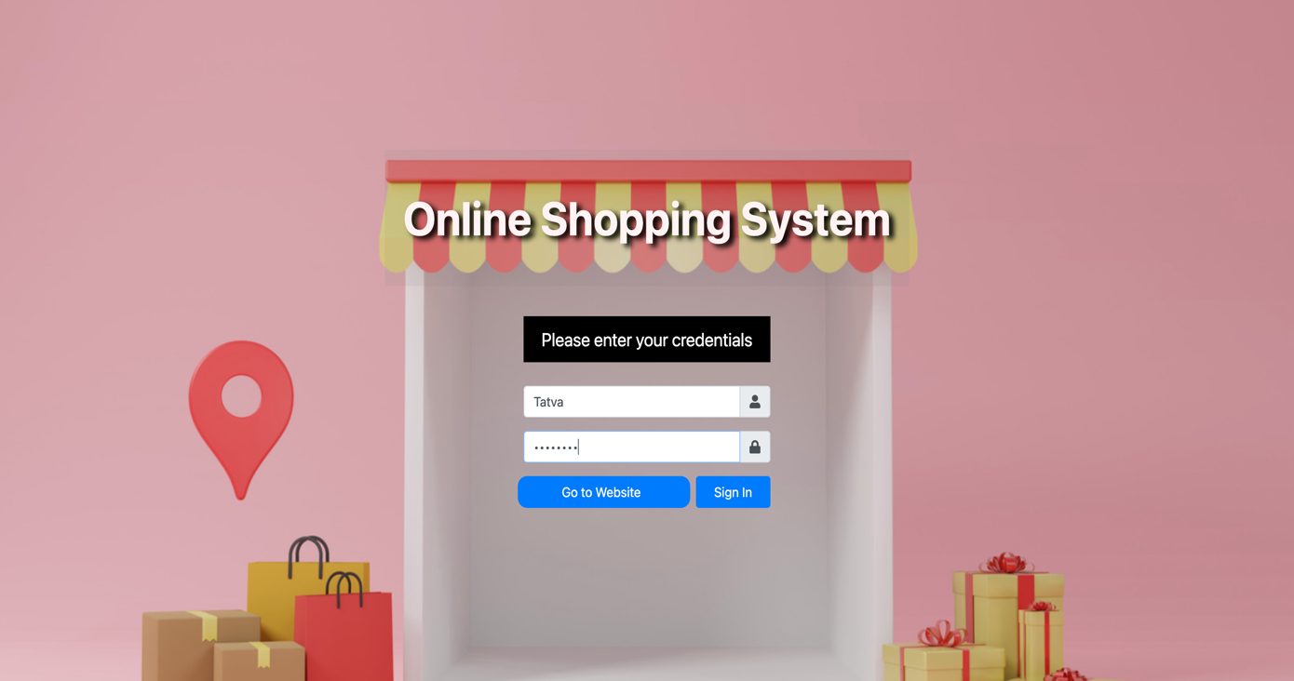

2. Admin Dashboard

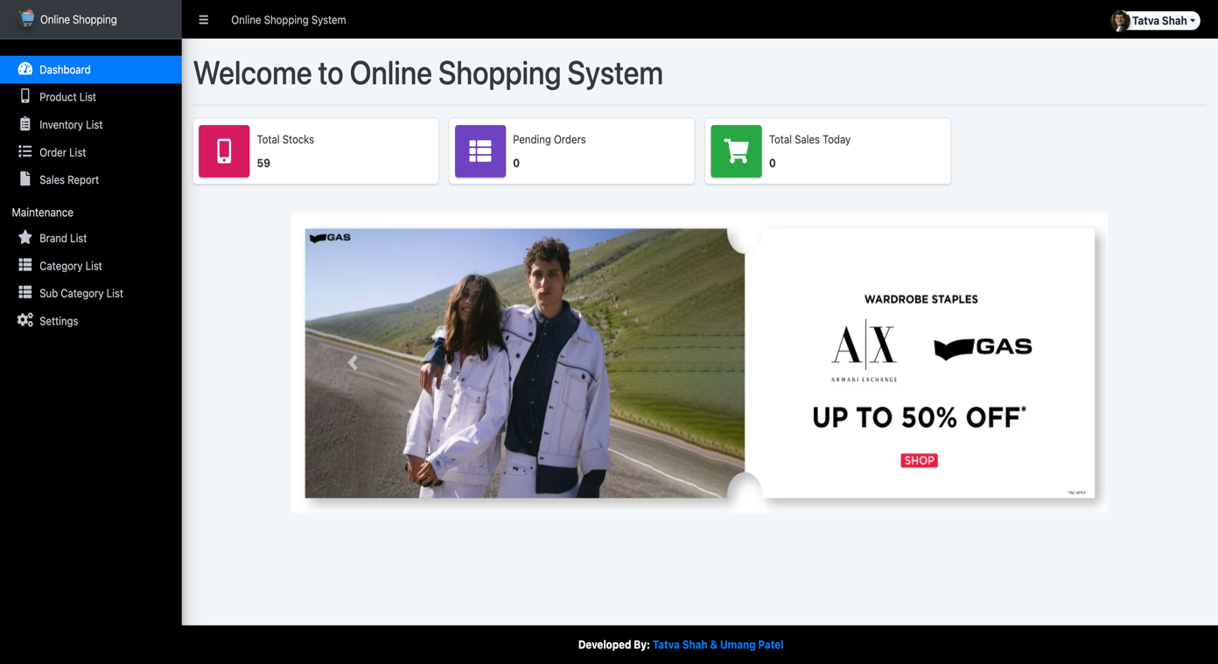

3. Admin Product list

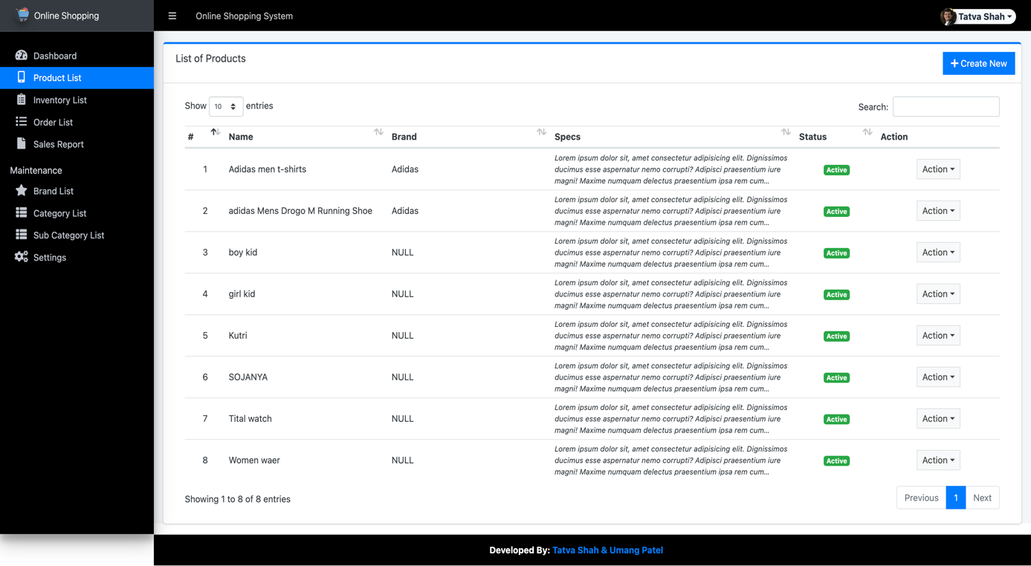

4. Admin Update Product

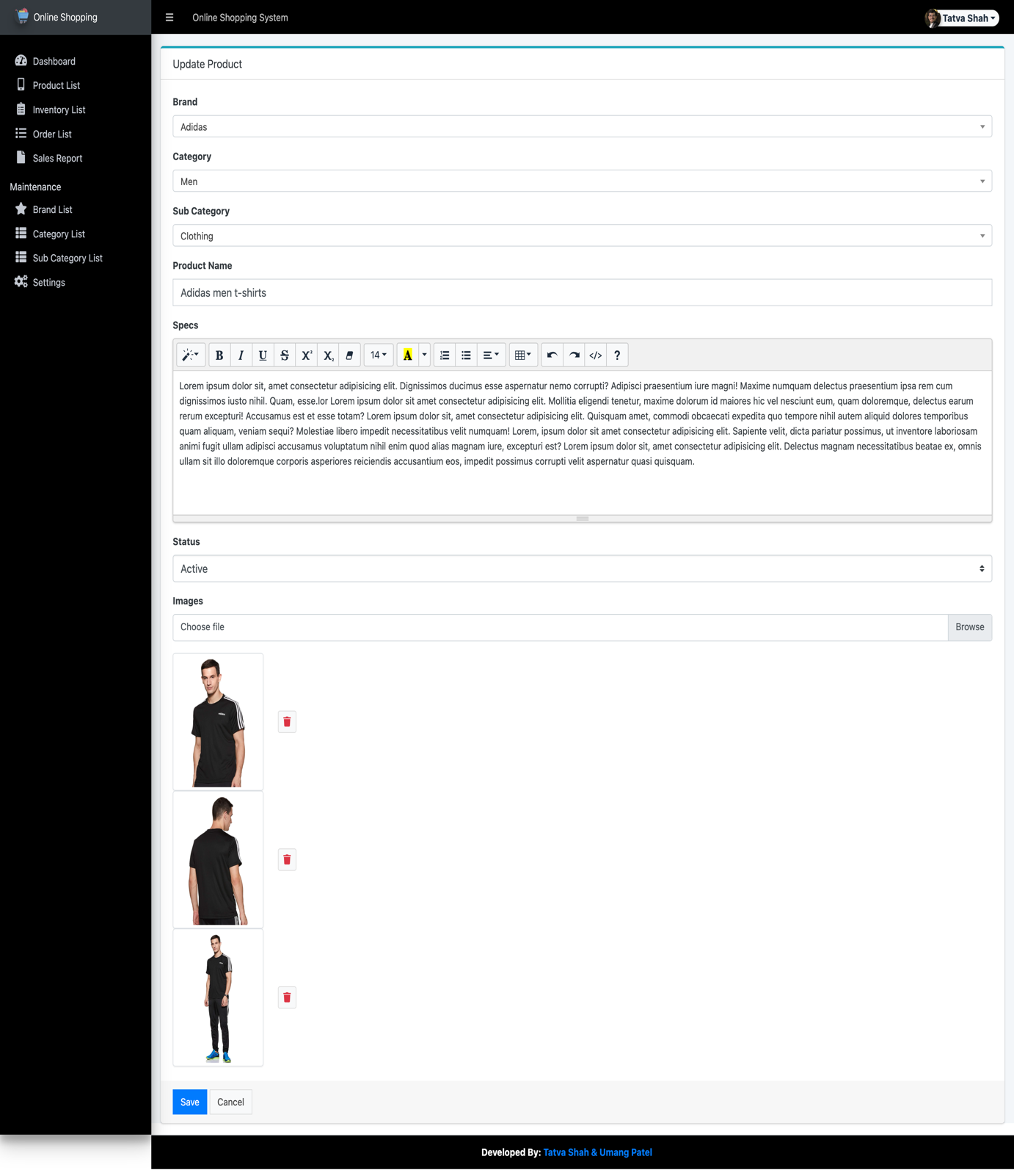

5. Admin Inventory list

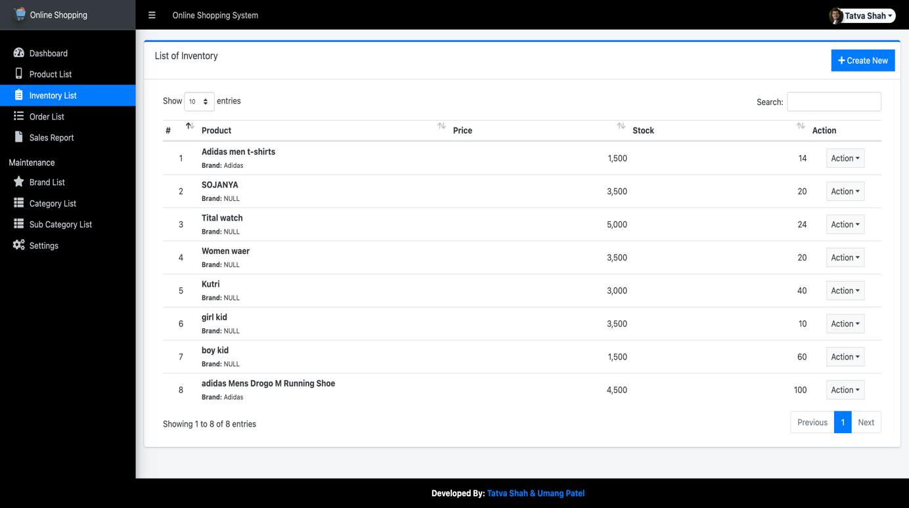

6. Admin Add Inventory

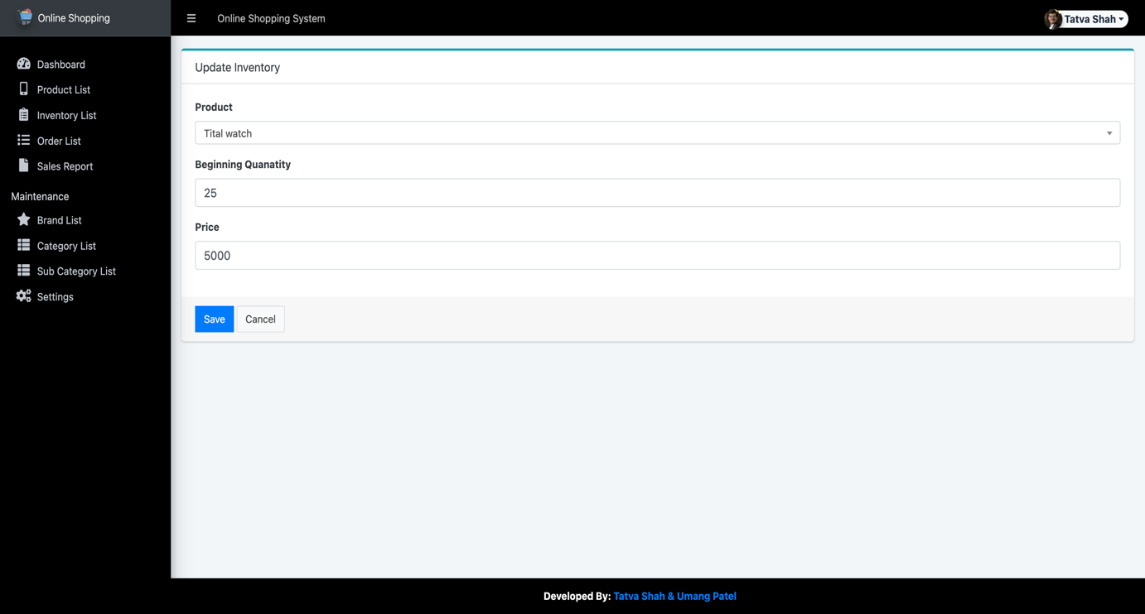

7. Admin Order list

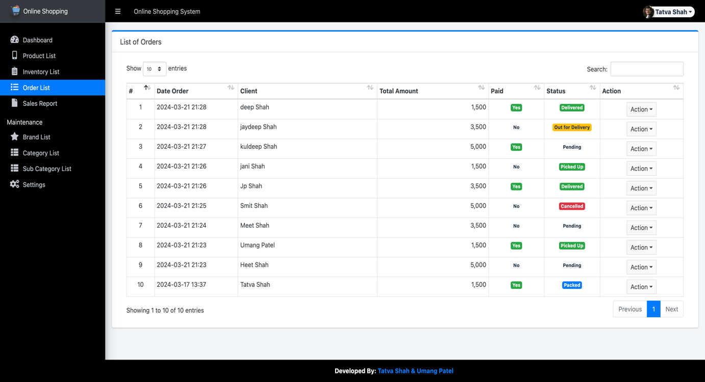

8. Admin Order Update

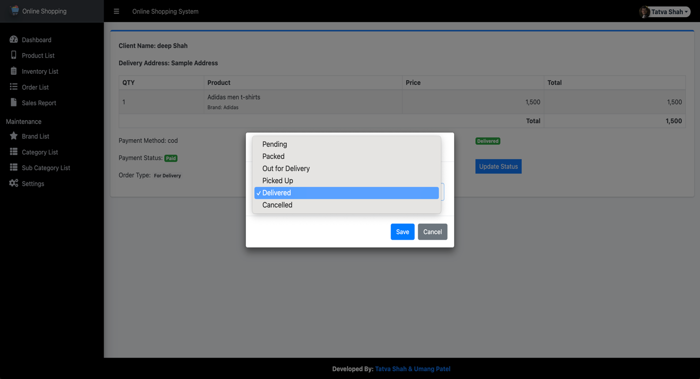

9. Admin Sales Report

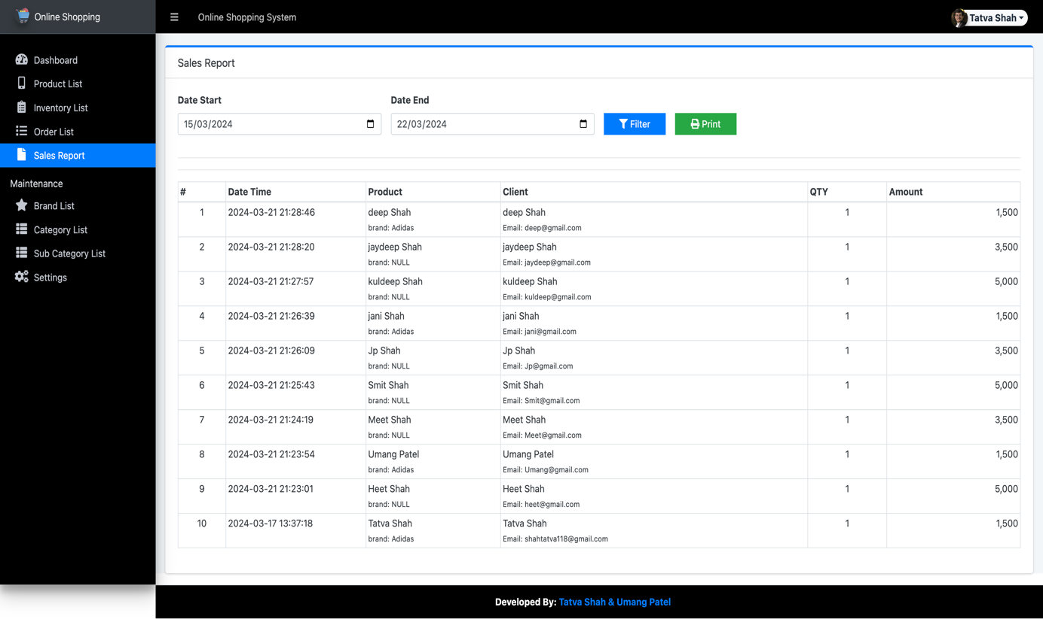

10. Admin Sales Report PDF

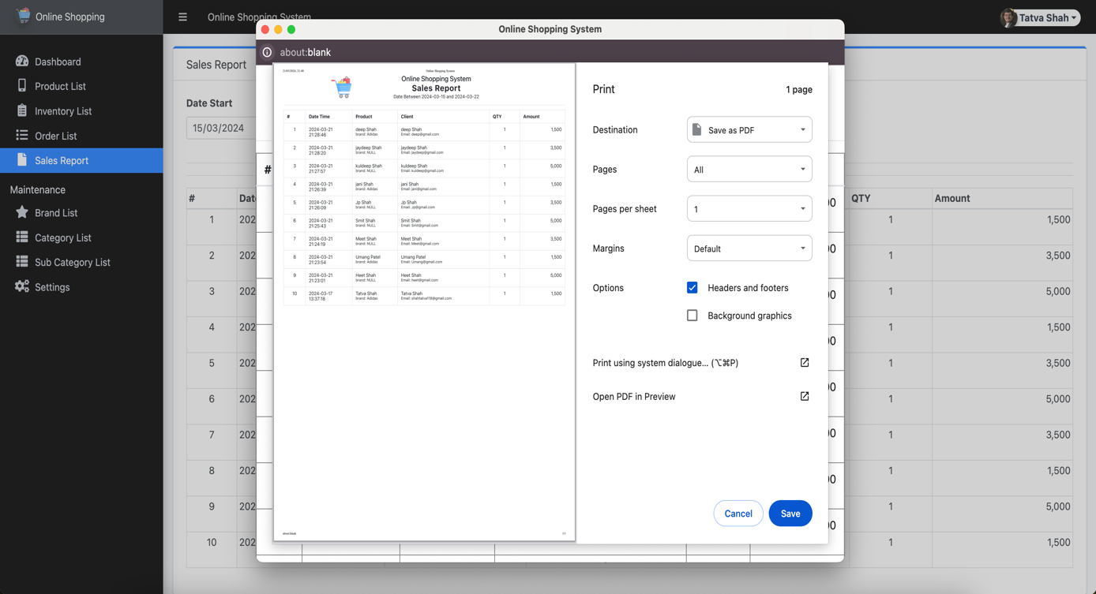

11. Admin Brand list

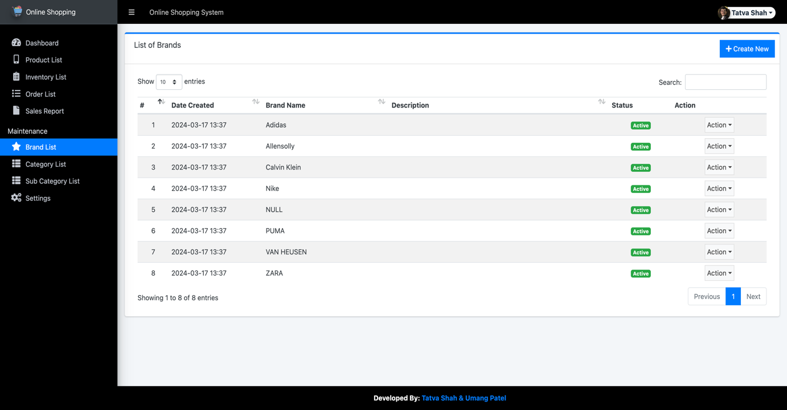

12. Admin Add Brand

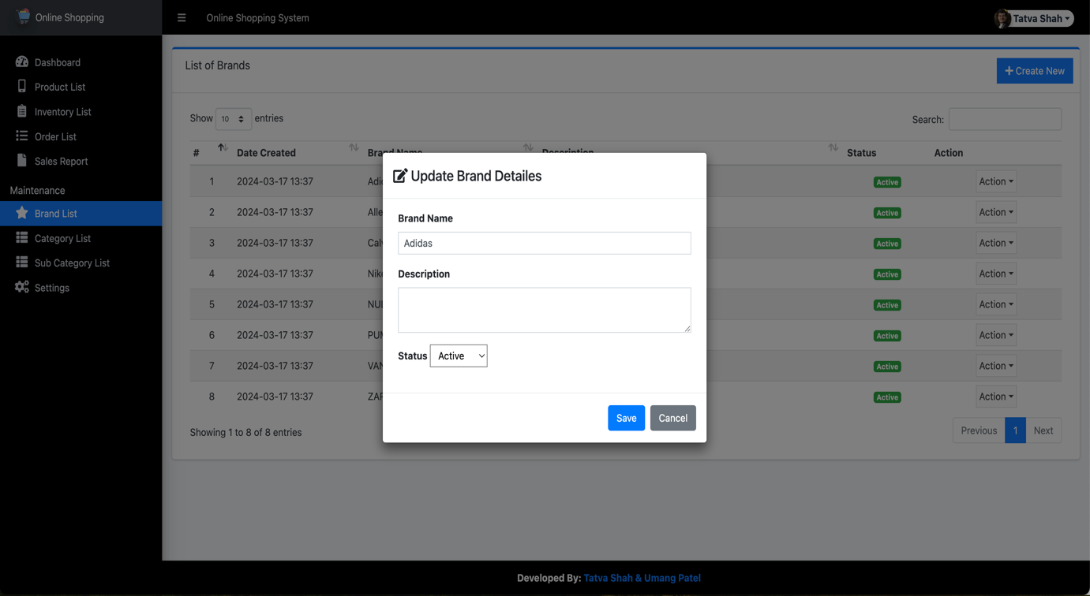

13. Admin Category list

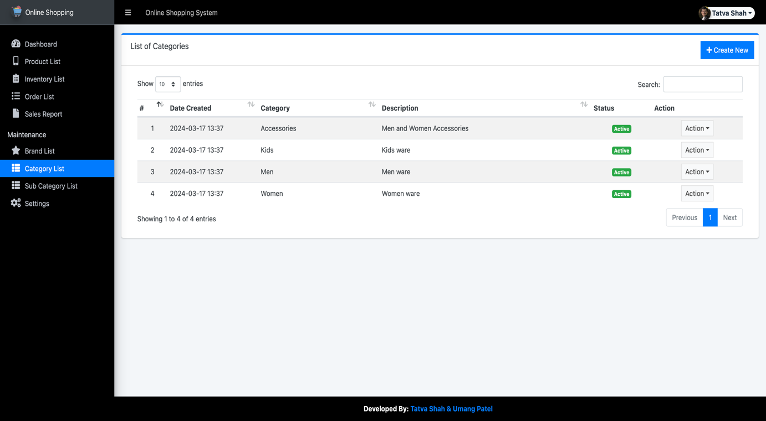

14. Admin Add Category

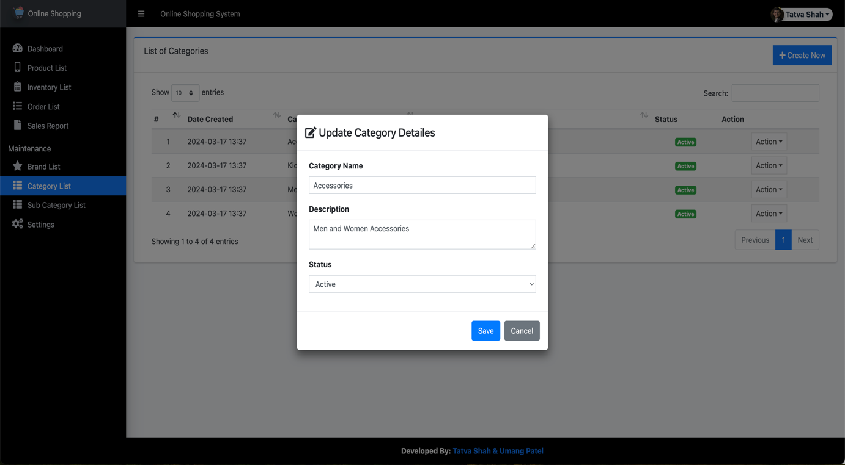

15. Admin Sub-Category list

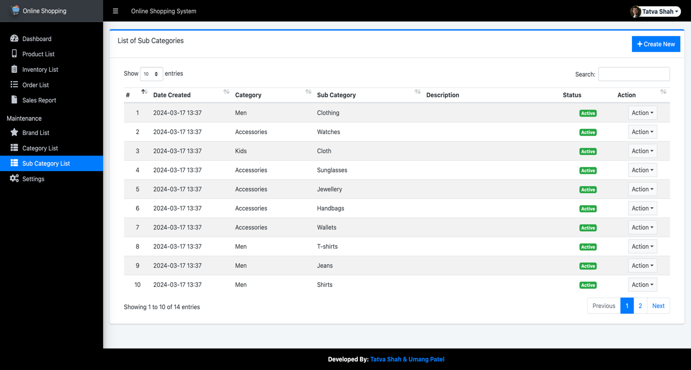

16. Admin Add Sub-Category

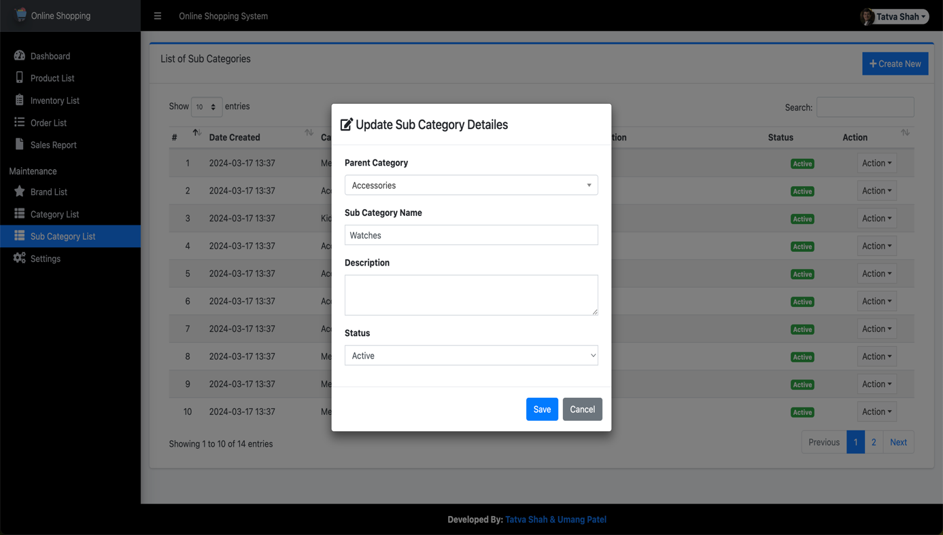

17. Admin Settings

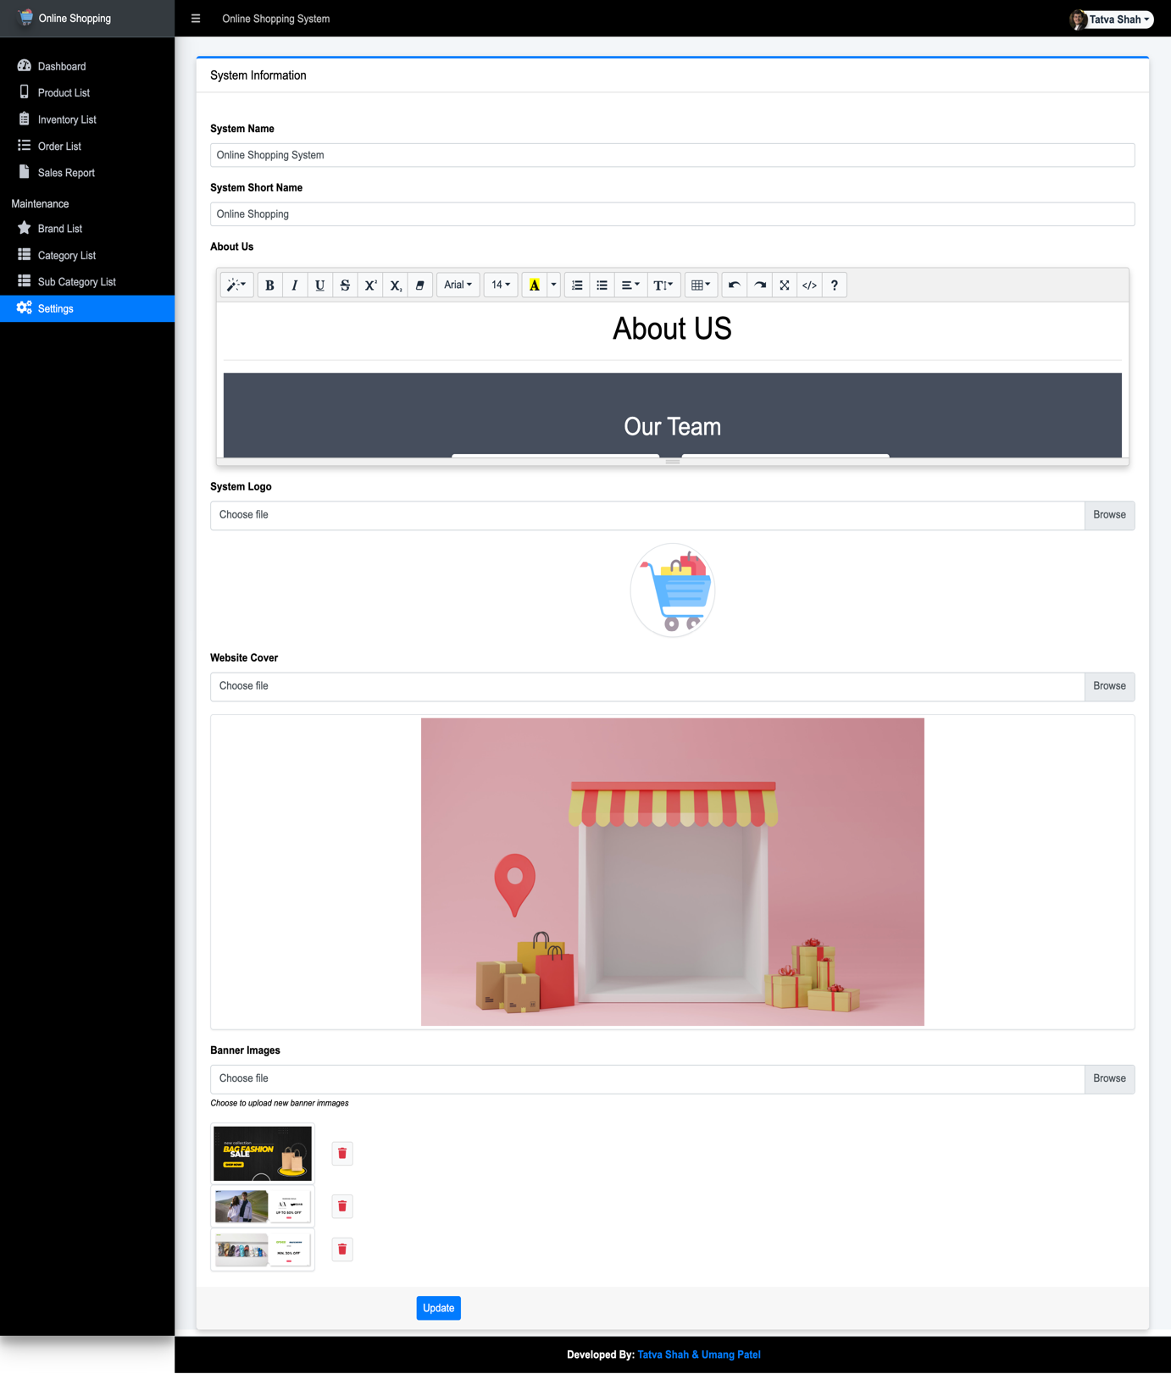

### Customer

18. Customer Registration page

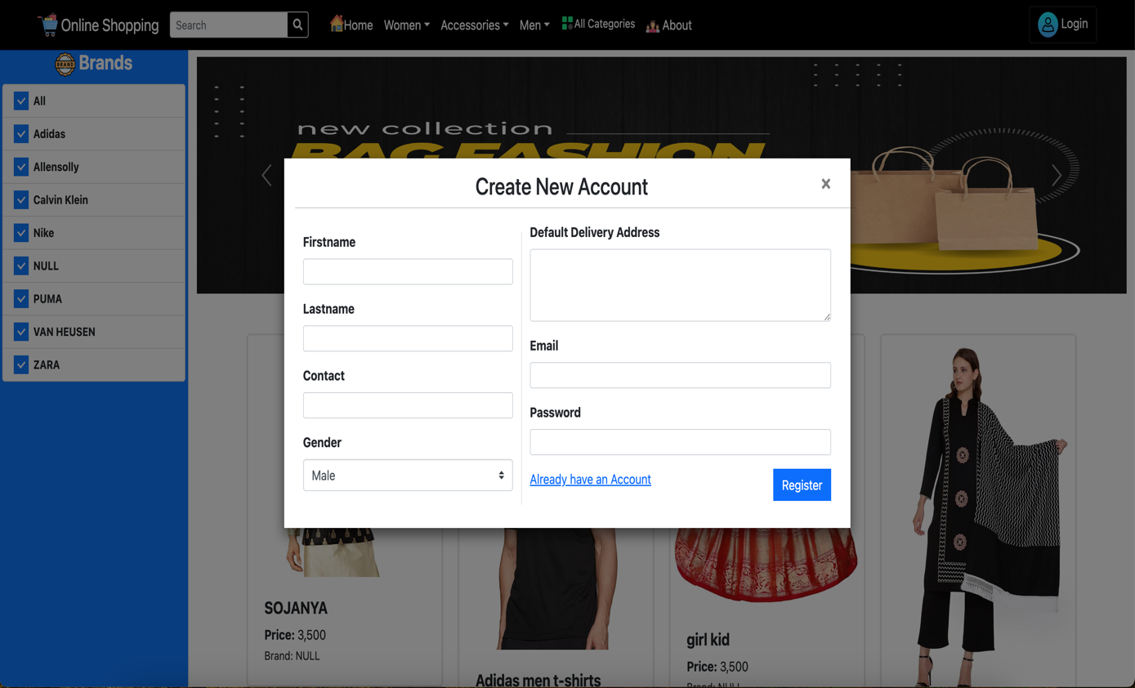

19. Customer Login page

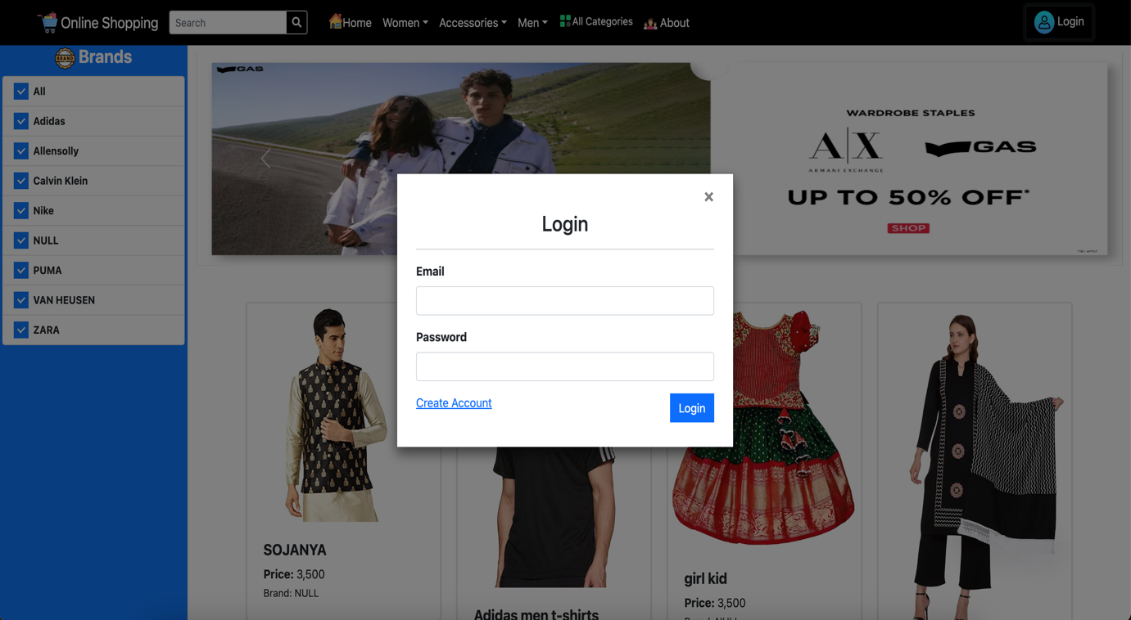

20. Customer Home page

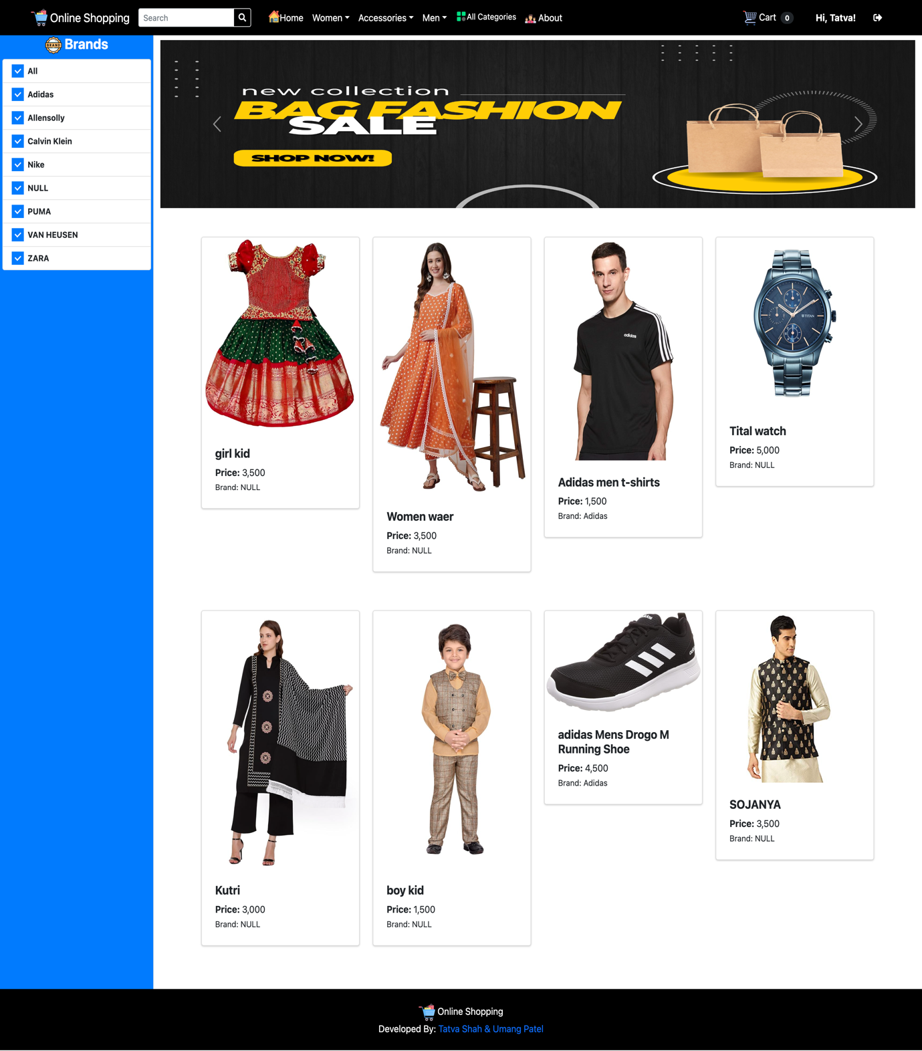

21. Customer View Product

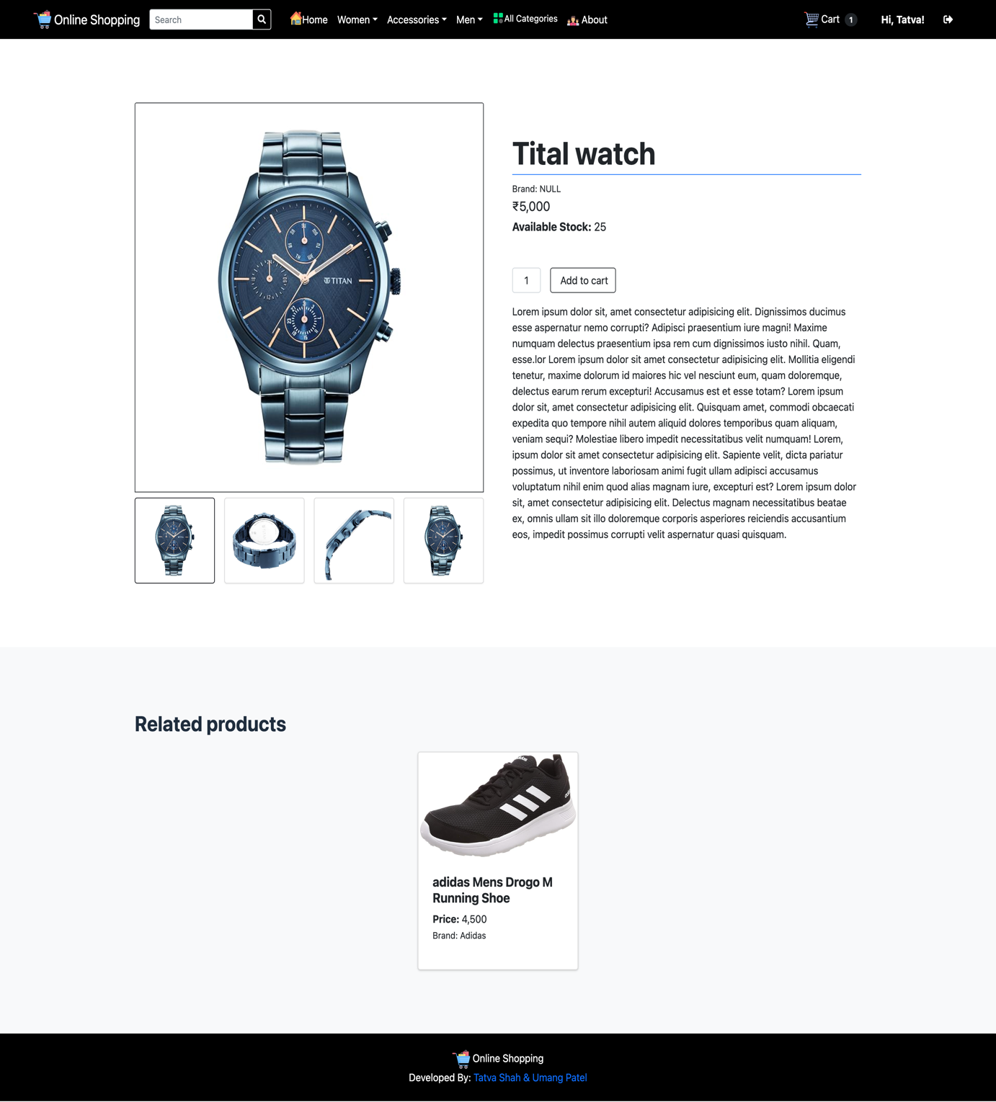

22. Customer All Categories

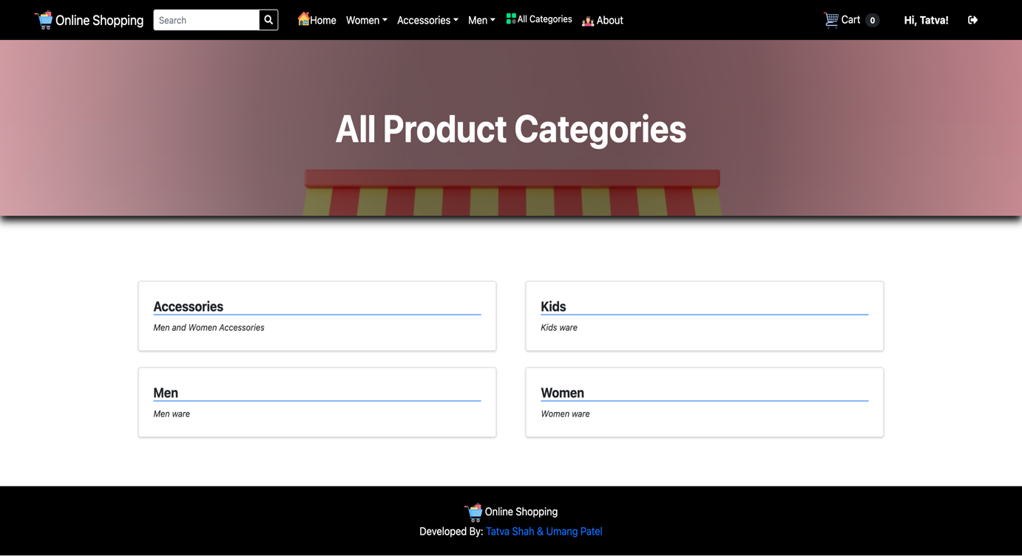

23. Customer Home page

* (Accessories)

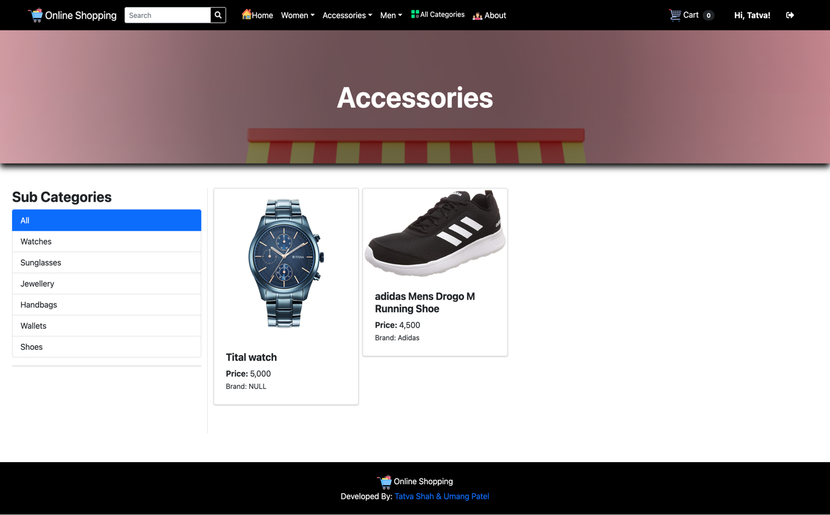

* (Men ware)

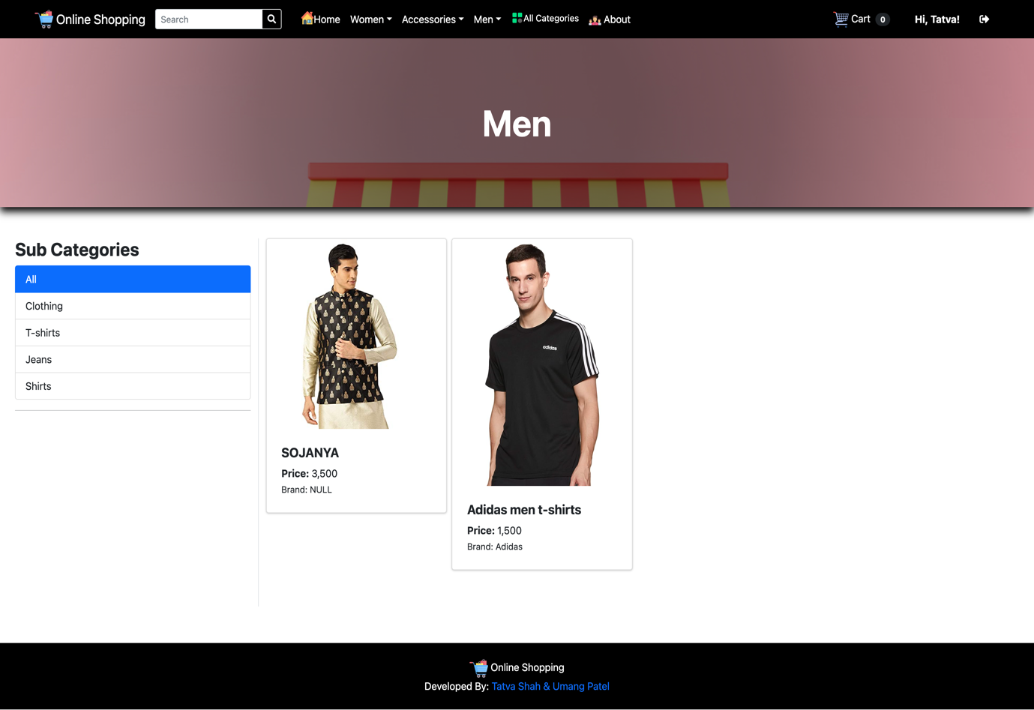

* (Women ware)

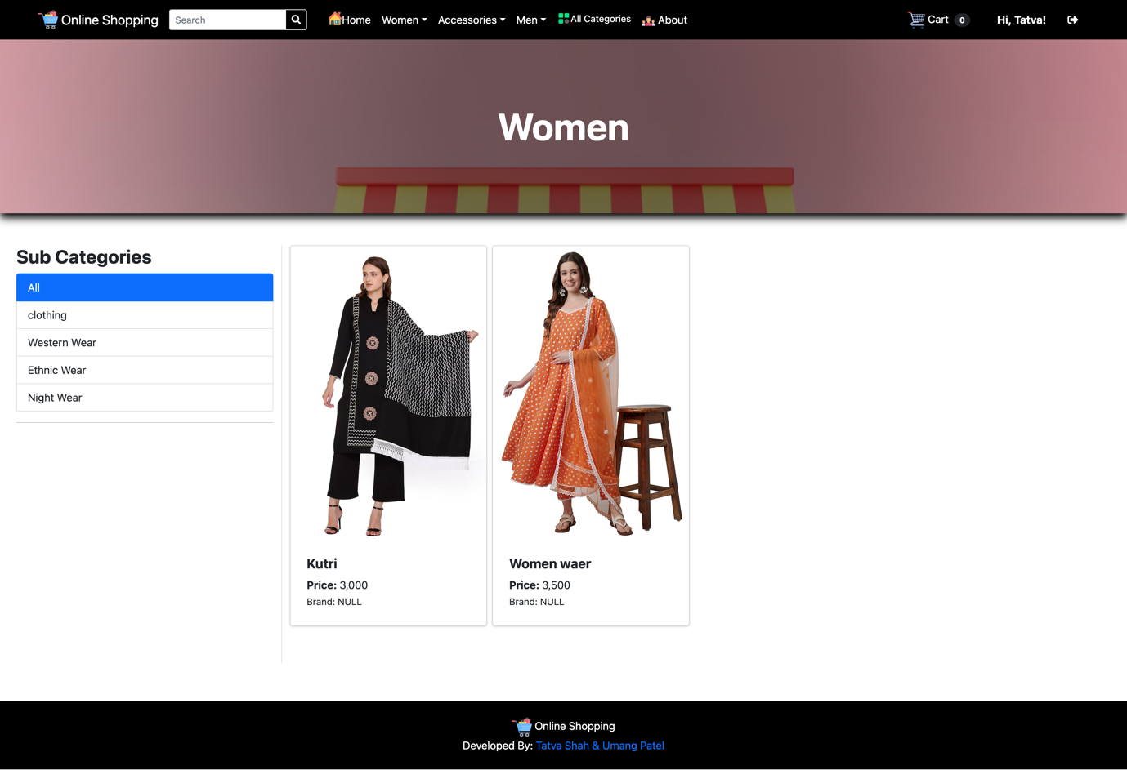

* (Kids ware)

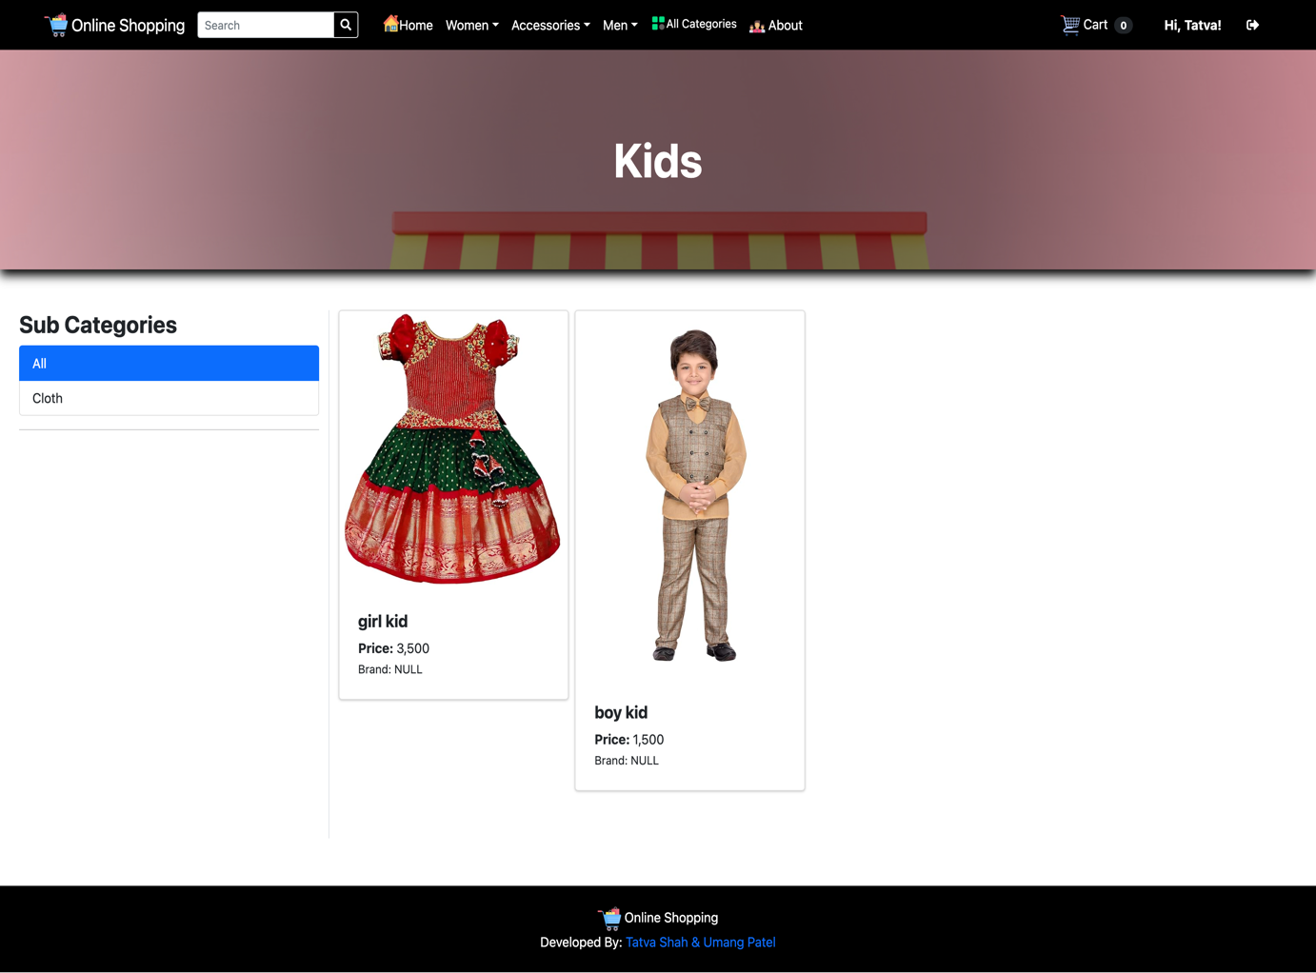

24. Customer Cart List

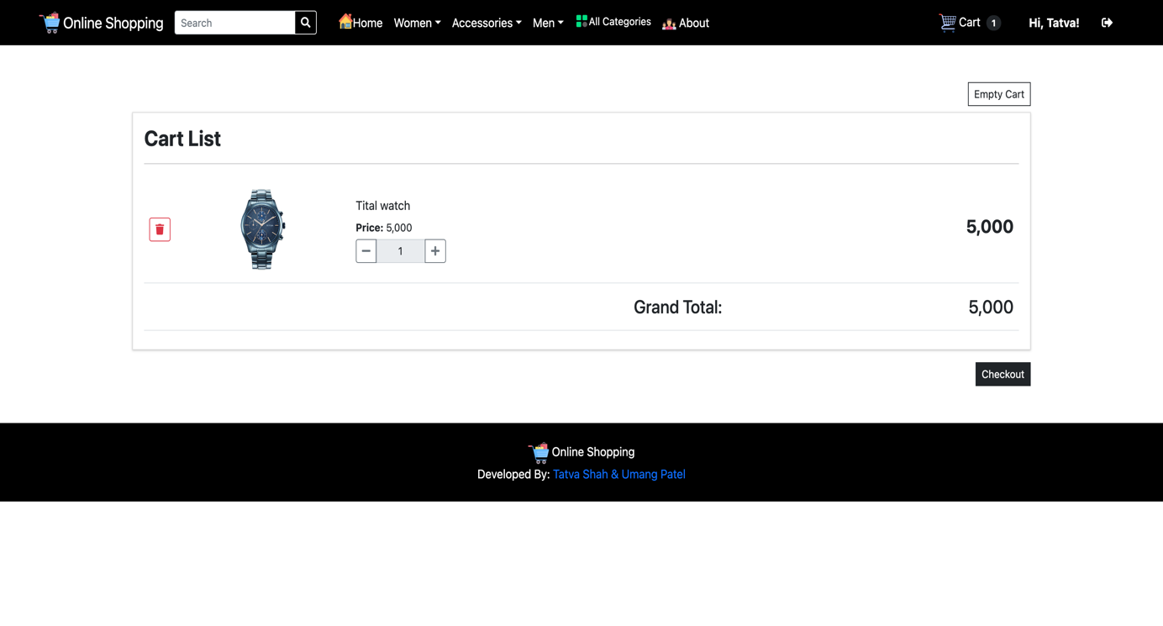

25. Customer Checkout

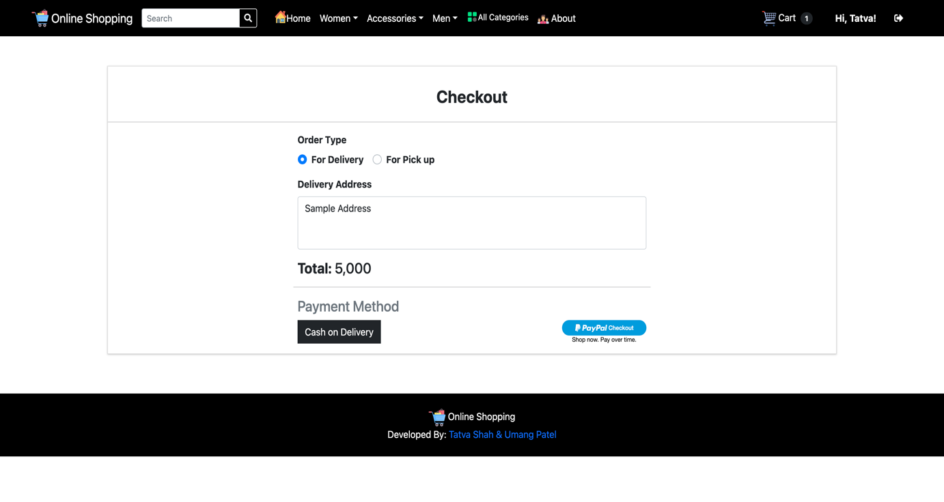

26. Customer Transaction ID

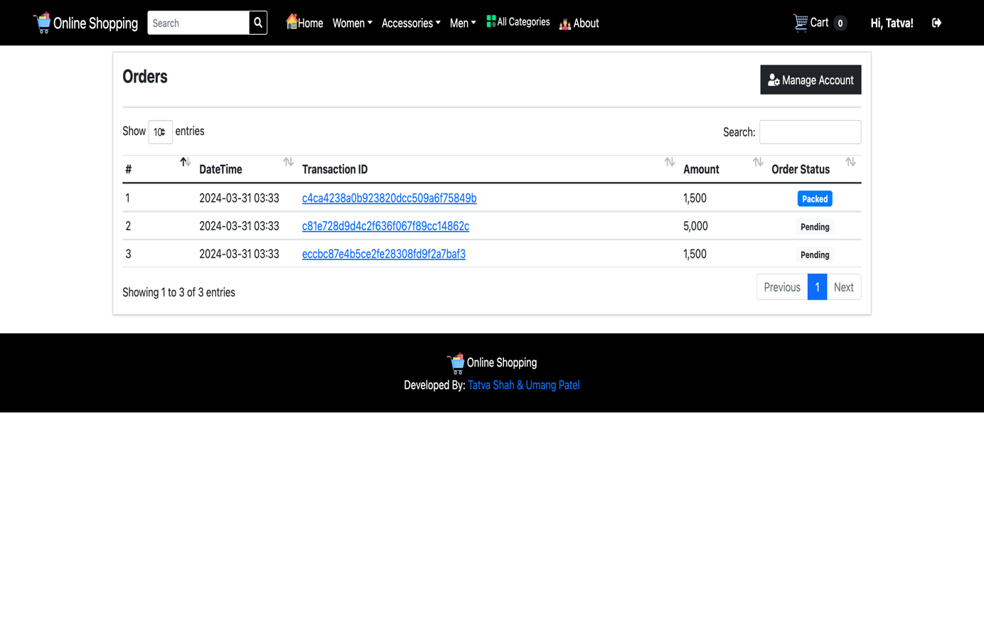

27. Customer Can Edit Profile

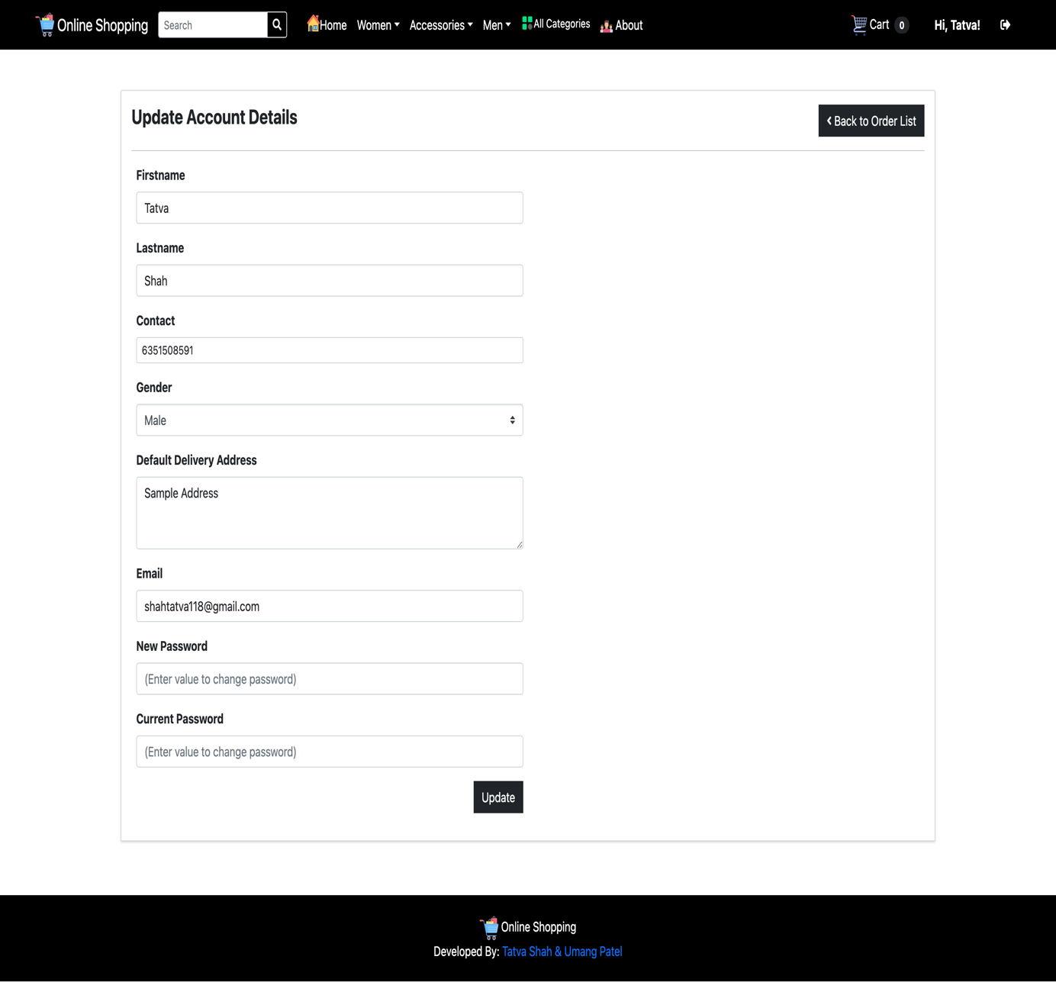

28. About Us

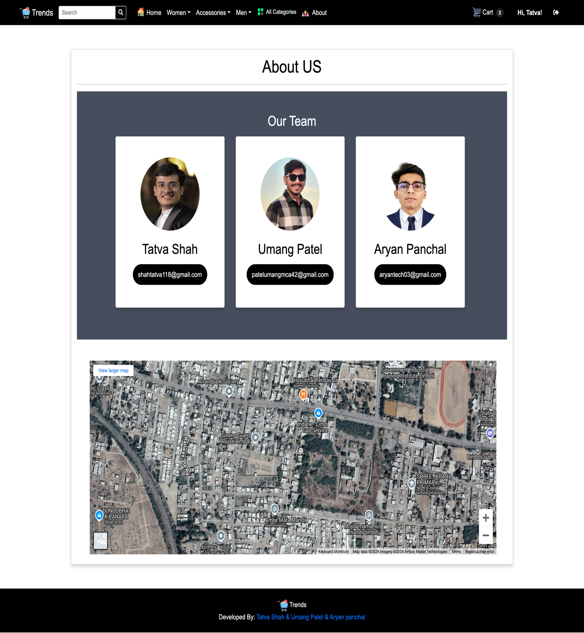

# Agile Documentation

## Agile Project Charter:

|  |  |
| --- | --- |
| General Project Information | |
| Project Name | Online Shopping system |
| Project Champion | Tatva Shah, Umang Patel, Aryan panchal |
| Project Sponsor | LJ Institute of Computer Application |
| Project Manager | Prof. **Pratvi ma’am** |
| Stakeholders | Admin , Customer |
| Expected Start Date | 14/8/2024 |
| Expected Completion Date | 27/9/2024 |

|  |  |
| --- | --- |
| Project Details | |
| Mission | We continuously innovate to be the best Shopping store for our customers. |
| Vision | E-commerce is when we use the internet to conduct business, think of it as an online market which organizes transactions between buyers and store owner. It eases access to many products and encourages international trade by making it more accessible than ever. |
| Scope | Admin can deal in a wide range of products. They can analyse customer buying different products offer, discounts, and services. Business can be easily scaled. By selling via online retail sites like Amazon, Flipkart, etc., |
| Date | 21/08/2024 |

## Agile Roadmap / Schedule

Agile Project Roadmap

|  |  |  |  |  |  |  |
| --- | --- | --- | --- | --- | --- | --- |
| **Sprint** | **Task Name** | **July14** | **July-31** | **Aug-1** | **sept-27** | **oct-14** |
| 1 | Project Structure |  | |  |  |  |
| 2 | Registration |  |  | |  |  |
| 3 | Login and Logout |  |  | |  |  |
| 4 | Forget Password |  |  |  |  |  |
| 5 | Manage Product (Admin) |  |  |  |  |  |
| 6 | Product (User) |  |  |  |  |  |
| 7 | Cart |  |  |  |  |  |
| 8 | Contact Us |  |  |  |  |  |
| 9 | Filters |  |  |  |  |  |
| 10 | Order |  |  |  |  |  |
| 11 | Payment |  |  |  |  |  |

## Agile Project Plan

|  |  |  |  |  |
| --- | --- | --- | --- | --- |
| **Task Name** | **Duration** | **Start** | **Finish** | **Status** |
| **Sprint#1: Project Structure** | 7d | 14/07/2024 | 18/07/2024 | Completed |
| UI Designing | 4d | 14/07/2024 | 14/07/2024 | Completed |
| Database Management | 3d | 18/07/2024 | 18/07/2024 | Completed |
| **Sprint#2: Registration** | 5d | 24/07/2024 | 24/07/2024 | Completed |
| Customer Registration | 5d | 24/07/2024 | 24/07/2024 | Completed |
| **Sprint#3: Login and Logout** | 4d | 28/07/2024 | 30/07/2024 | Completed |
| Customer Login | 2d | 28/07/2024 | 28/07/2024 | Completed |
| Admin Login | 3d | 30/07/2024 | 30/07/2024 | Completed |
| **Sprint#4: Forget Password** | 2d | 02/08/2024 | 02/08/2024 | Completed |
| Customer changes Password | 2d | 02/08/2024 | 02/08/2024 | Completed |
| **Sprint#5: Manage Product (Admin)** | 9d | 03/08/2024 | 03/08/2024 | Completed |
| Add, Update, View, Delete | 9d | 03/08/2024 | 03/08/2024 | Completed |
| **Sprint#6: Product (customer)** | 5d | 12/08/2024 | 17/08/2024 | Completed |
| View Products | 2d | 14/08/2024 | 14/08/2024 | Completed |
| View Product Details | 3d | 17/08/2024 | 17/08/2024 | Completed |
| **Sprint#7: Cart** | 6d | 18/08/2024 | 22/08/2024 | Completed |
| View Cart | 2d | 19/08/2024 | 19/08/2024 | Completed |
| Add and Delete from Cart | 4d | 22/08/2024 | 22/08/2024 | Completed |
| **Sprint#8: Contacts** | 1d | 23/08/2024 | 23/08/2024 | Completed |
| Contact to Admin | 1d | 23/08/2024 | 23/8/2024 | Completed |
| **Sprint#9: Order** | 19d | 1/9/2024 | 19/9/2024 | Completed |
| Customer Place Order | 19d | 19/9/2024 | 19/9/2024 | Completed |
| **Sprint#10: Filters** | 6d | 20/9/2024 | 25/9/2024 | Completed |
| By Product Category | 3d | 22/9/2024 | 22/9/2024 | Completed |
| By Product Size | 2d | 22/9/2024 | 22/9/2024 | Completed |
| By Brand | 3d | 25/9/2024 | 25/9/2024 | Completed |
| **Sprint#11: Payment** | 1d | 27/9/2024 | 27/9/2024 | Completed |
| Cash on Delivery | 1d | 27/9/2024 | 27/9/2024 | Completed |
| Online Payment | 1d | 27/9/2024 | 27/9/2024 | Completed |

## Agile User Story

|  |  |  |  |
| --- | --- | --- | --- |
| **User Story ID** | **As a (type of user)** | **I want to (perform some task)** | **So that I can (achieve some goal)** |
| **1** | Admin | Manage Login Module | Ensure that validate user can join |
| **2** | Admin | Manage Product | Insert, Update Delete and View the product |
| **3** | Admin | Manage order | Ensures the order information is valid |
| **4** | Visitor | View Product | View products  according to categories |
| **5** | Customer | View Product | View products according to  categories |
| **6** | Customer | Add to Cart | Products are added to cart to buy bunch of products in single order |
| **7** | Customer | Order product | To see what they had purchase in the past |
| **8** | Customer | Make Payment | Payment for the order |
| **9** | Customer | Search Product | Search products according to their requirement |
| **10** | Customer | Order | Order products |

## Agile Release Plan

|  |  |  |  |  |
| --- | --- | --- | --- | --- |
| **Task Name** | **Duration** | **Start** | **Finish** | **Release Date** |
| **Sprint#1: Project Structure** | 7d | 14/01/2024 | 18/01/2024 | 18/01/2024 |
| UI Designing | 4d | 14/01/2024 | 14/01/2024 | 14/01/2024 |
| Database Management | 3d | 18/01/2024 | 18/01/2024 | 18/01/2024 |
| **Sprint#2: Registration** | 5d | 24/01/2024 | 24/01/2024 | 24/01/2024 |
| Customer Registration | 5d | 24/01/2024 | 24/01/2024 | 24/01/2024 |
| **Sprint#3: Login and Logout** | 4d | 28/01/2024 | 30/01/2024 | 30/01/2024 |
| Customer Login | 2d | 28/01/2024 | 28/01/2024 | 28/01/2024 |
| Admin Login | 3d | 30/01/2024 | 30/01/2024 | 30/01/2024 |
| **Sprint#4: Forget Password** | 2d | 02/02/2024 | 02/02/2024 | 02/02/2024 |
| Change Customer Password | 2d | 02/02/2024 | 02/02/2024 | 02/02/2024 |
| **Sprint#5: Manage Product (Admin)** | 9d | 03/02/2024 | 03/02/2024 | 03/02/2024 |
| Add, Update, View and  Delete | 9d | 03/02/2024 | 03/02/2024 | 03/02/2024 |
| **Sprint#6: Product (customer)** | 5d | 12/02/2024 | 17/02/2024 | 17/02/2024 |
| View products | 2d | 14/02/2024 | 14/02/2024 | 14/02/2024 |
| View product details | 3d | 17/02/2024 | 17/02/2024 | 17/02/2024 |
| **Sprint#7: Cart** | 6d | 18/02/2024 | 22/02/2024 | 22/02/2024 |
| View cart | 2d | 19/02/2024 | 19/02/2024 | 19/02/2024 |
| Add and delete from cart | 4d | 22/02/2024 | 22/02/2024 | 22/02/2024 |
| **Sprint#8: Contacts** | 1d | 23/02/2024 | 23/02/2024 | 23/02/2024 |
| Contact to Admin | 1d | 23/2/2024 | 23/2/2024 | 23/2/2024 |
| **Sprint#9: Order** | 19d | 1/3/2024 | 19/3/2024 | 19/3/2024 |
| Customer Place Order | 19d | 19/3/2024 | 19/3/2024 | 19/3/2024 |
| **Sprint#10: Filters** | 6d | 20/3/2024 | 25/3/2024 | 25/3/2024 |
| By Product Category | 3d | 22/3/2024 | 22/3/2024 | 22/3/2024 |
| By Product Size | 2d | 22/3/2024 | 22/3/2024 | 22/3/2024 |
| By Brand | 3d | 25/3/2024 | 25/3/2024 | 25/3/2024 |
| **Sprint#11: Payment** | 1d | 27/3/2024 | 27/3/2024 | 27/3/2024 |
| Cash on Delivery | 1d | 27/3/2024 | 27/3/2024 | 27/3/2024 |
| Online Payment | 1d | 27/3/2024 | 27/3/2024 | 27/3/2024 |

## Agile Sprint Backlog

|  |  |  |  |  |  |
| --- | --- | --- | --- | --- | --- |
| **Task Name** | **Story** | **Sprint Ready** | **Priority** | **Status** | **Story Point** |
| **Sprint#1: Project Structure** | Yes | Yes | High | Completed | 3 |
| UL Designing | Yes | Yes | High | Completed | 2 |
| Database Management | Yes | Yes | High | Completed | 2 |
| **Sprint#2: Registration** | Yes | Yes | High | Completed | 2 |
| Customer Registration | Yes | Yes | High | Completed | 1 |
| **Sprint#3: Login & Logout** | Yes | Yes | High | Completed | 4 |
| Customer Login | Yes | Yes | High | Completed | 4 |
| Admin Login | Yes | Yes | High | Completed | 4 |
| **Sprint#4: Forget Password** | Yes | Yes | High | Completed | 3 |
| Customer changes Password | Yes | Yes | High | Completed | 3 |
| **Sprint#5: Manage Product (Admin)** | Yes | Yes | High | Completed | 4 |
| Add, Update, View and Delete | Yes | Yes | High | Completed | 4 |
| **Sprint#6: Product (customer)** | Yes | Yes | High | Completed | 4 |
| View products | Yes | Yes | High | Completed | 4 |
| View product details | Yes | Yes | High | Completed | 4 |
| **Sprint#7: Cart** | Yes | Yes | Medium | Completed | 4 |
| View cart | Yes | Yes | High | Completed | 4 |
| Add and delete from cart | Yes | Yes | Medium | Completed | 2 |
| **Sprint#8: Contacts** | Yes | Yes | Low | Completed | 1 |
| Contact to admin | Yes | Yes | Low | Completed | 1 |
| **Sprint#9: Order** | Yes | Yes | High | Completed | 4 |
| Customer Order | Yes | Yes | High | Completed | 4 |
| **Sprint#10: Filters** | Yes | Yes | Medium | Completed | 2 |
| By Product Category | Yes | Yes | Medium | Completed | 2 |
| By Product Size | Yes | Yes | Medium | Completed | 2 |
| By Brand | Yes | Yes | Medium | Completed | 2 |
| **Sprint#11: Payment** | Yes | Yes | High | Completed | 5 |
| Cash on Delivery | Yes | Yes | High | Completed | 3 |
| Online Payment | Yes | Yes | High | Completed | 5 |

## Agile Test Plan

|  |  |
| --- | --- |
| **Test Case ID: 101** | **Test Case Name: Customer Login** |
| **Designed by**: **Tatva shah** | **Design Date: 10/01/2024** |
| **Module Name: User Login** | **Sub Module Name: Login** |
| **Executed by: Tatva shah** | **Execution Date: 10/03/2024** |
| **Brief Description: User Login**  **With Data: “email: shahtatva118@gmail.com& password:tatva123”** | **Test Priority (Low/Medium/High): High** |
| **Pre-Conditions: User Must Registered**  **& have** | **Correct Username & Password.** |
| **Dependencies: None** |  |

|  |  |  |  |  |  |
| --- | --- | --- | --- | --- | --- |
| **Test Step** | **Test Data** | **Expected Result** | **Actual Result** | **Status (Pass/Fail)** | **Remarks** |
| 1 | **Email:** t@g.com  **Password:** 1234 | Successfully login & redirect to  Home Page. | Login Successful. | Pass | None |
| 2 | **Email:** t1@g.com  **Password:** 1234 | Show “Invalid Credentials.” | Login Not Successful | Fail | Need to Show Error  Message. |
| 3 | **Email:** t2@g.com  **Password:** 1234Mah | Show “Invalid Credentials.” | Login Not Successful | Fail | Need to Show Error  Message. |
| 4 | **Email:** t2@g.com  **Password:** 1234 | Successfully login in to system &  redirect to home Page. | Login Successful & Redirect to home Page. | Pass | None |

|  |  |
| --- | --- |
| **Test Case ID: 102** | **Test Case Name: User Registration** |
| **Designed by: Umang patel** | **Design Date: 10/01/2024** |
| **Module Name: User Registration** | **Sub Module Name: Register** |
| **Executed by: Umang patel** | **Execution Date: 10/03/2024** |
| **Brief Description: User Registration page for the new user. User needs to provide**  **the correct details for Registration.** | **Test Priority (Low/Medium/High): High** |
| **Pre-conditions: None** | |
| **Dependencies: Username & Password are store.** | |

|  |  |  |  |  |  |
| --- | --- | --- | --- | --- | --- |
| **Test Step** | **Test Data** | **Expected Result** | **Actual Result** | **Status (Pass/Fail)** | **Remarks** |
| 1 | **First Name:** umang **Last Name:** patel **Email:** [u@gmail.com](mailto:u@gmail.com) **Password:** 1234 **Confirm Password:**  1234 | Successfully Registered & Redirect to Login Page. | Registered Successfully. | Pass | redirect to login Page. |
| 2 | **First Name:** umang **Last Name:** patel **Email:** [u1@gmail.com](mailto:u1@gmail.com) **Password:** 1234 **Confirm Password:**  12345 | Show Error Message as “Password & Confirm  Password must be Equal” | Not Registered & remain in Registration page. | Fail | None |
| 3 | **First Name:** Piyush **Last Name:** Jain **Email:** [u2@gmail.com](mailto:u2@gmail.com) **Password:** 1234 **Confirm Password:**  1234 | Show Error Message as “Email  I’d Already Exist” | Not Registered & remain in Registration page. | Fail | None |
| 4 | **First Name:** Tushar **Last Name:** Sid **Email:** [u3@gmail.com](mailto:u3@gmail.com) **Password:** 4321 **Confirm Password:**  4321 | Successfully Registered & | Successfully Registered & | Pass | None |

|  |  |
| --- | --- |
| **Test Case ID: 103** | **Test Case Name: Add Product (Admin)** |
| **Designed by: Tatva Shah** | **Design Date: 10/01/2024** |
| **Module Name: Add Product Module** | **Sub Module Name: Add Product** |
| **Executed by: Tatva Shah** | **Execution Date: 10/03/2024** |
| **Brief Description: Admin can Add the**  **Products.** | **Test Priority (Low/Medium/High): High** |
| **Pre-conditions: Admin must be Logged in.** | |
| **Dependencies: None** | |

|  |  |  |  |  |  |
| --- | --- | --- | --- | --- | --- |
| **Test** | **Test Step** | **Action** | **Expected Result** | **Actual Result** | **Status (Pass/Fail)** |
| 1 | Click on Add  Product | Open  product details page | Show form for  Entering details | Show form for  Entering details | Pass |
| 2 | Fill Product Details. | Taking Valid product  details | Validation of input data | Validation of input data | Pass |
| 3 | Submit data | Click on save button | Add product and show it to admin | Add product and show it to admin | Pass |

|  |  |
| --- | --- |
| **Test Case ID: 104** | **Test Case Name: Cart** |
| **Designed by: Umang Patel** | **Design Date:** 10/01/2024 |
| **Module Name: Cart Module** | **Sub Module Name:** Add to Cart Product |
| **Executed by: Umang Patel** | **Execution Date:** 10/03/2024 |
| **Brief Description: User can Add the**  **Products in Cart.** | **Test Priority (Low/Medium/High):** High |
| **Pre-conditions: User must be Logged in.** | |
| **Dependencies: None** | |

|  |  |  |  |  |  |
| --- | --- | --- | --- | --- | --- |
| **Test** | **Test Step** | **Action** | **Expected Result** | **Actual Result** | **Status (Pass/Fail)** |
| 1 | Click on add to cart Button | Product should be added to cart | Product should be added to cart and  display the cart page. | Product should not be added to cart. | Fail |
| 2 | Click on add to cart Button | Product should be added to cart | Product should be added to cart and display the cart  page. | Product should be added to cart and display the  cart page. | Pass |
| 3 | Click on (+) Increase Button | Added Product count Increase | In a cart Product count Increase add same item multiple time | In a cart Product count Increase add same  Product multiple time | Pass |
| 4 | Click on (-) Increase Button | Added Product count Decrease &  Delete | In a cart Product count Decrease & Delete/remove | In a cart Product count Decrease & Delete/remove | Pass |
| **5** | Click on Cart Button | Add the Product in Cart | able to add multiple Product in to cart | able to add multiple Product in to cart | Pass |

|  |  |
| --- | --- |
| **Test Case ID: 105** | **Test Case Name: Payment** |
| **Designed by: Tatva Shah** | **Design Date: 10/01/2024** |
| **Module Name: Payment** | **Sub Module Name:** Payment |
| **Executed by: Tatva Shah** | **Execution Date: 10/03/2024** |
| **Brief Description: payment for products** | **Test Priority (Low/Medium/High):** High |
| **Pre-conditions: User must be Logged in.** | |
| **Dependencies: None** | |

|  |  |  |  |  |  |
| --- | --- | --- | --- | --- | --- |
| **Test** | **Test Step** | **Action** | **Expected Result** | **Actual Result** | **Status (Pass/Fail)** |
| 1 | Click on Checkout Button | Show the All-Payment options | All the Payment options are visible | All the Payment options are visible | Pass |
| 2 | Click on Cash on Delivery Option | Selected option  Process is Start | Start the process and Product Order  is Done Successfully | Start the process and Product  Order is Done Successful | Pass |
| 3 | Click On Cart Online Payment | Need To Filled up All mandatory information | Start online Payment Process | Start online Payment Process | Pass |
| 4 | Successful for add the mandatory information | Ask for right strip number, cvv, date | Online payment Process is Done Successfully | Online payment Process is Done Successfully | Pass |
| 5 | Successful for add the mandatory information | Ask strip number, cvv, date | If Add Credit card or Dedit card Number | Online payment Process is Not start | Fail |
| 6 | Successful for add the mandatory information | Ask for wrong strip number, cvv, date | Online payment Process is Not start | Online payment Process is Not start | Fail |

## Earned-value and burn charts

|  |  |  |
| --- | --- | --- |
| Task | Plan Days | Actual Days |
| 0 |  |  |
| 1 | 5 | 7 |
| 2 | 3 | 5 |
| 3 | 3 | 4 |
| 4 | 2 | 2 |
| 5 | 6 | 9 |
| 6 | 4 | 5 |
| 7 | 5 | 6 |
| 8 | 1 | 1 |
| 9 | 10 | 15 |
| 10 | 5 | 8 |
| 11 | 5 | 10 |

**Burn Chart**

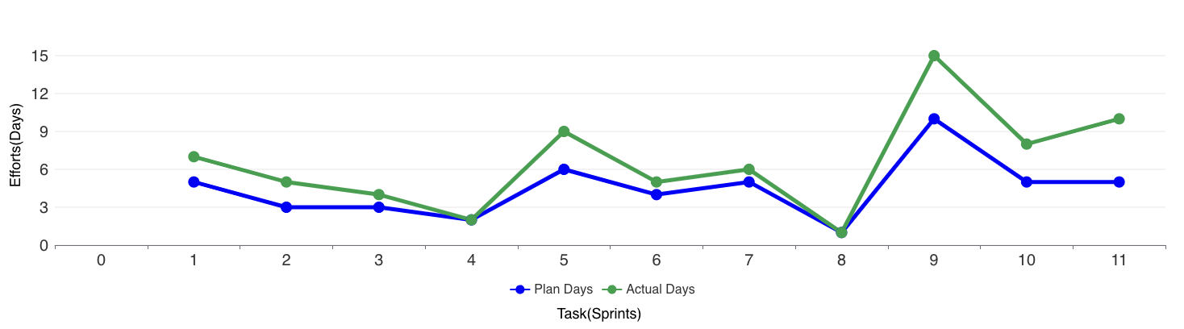

# Proposed Enhancements

## Proposed Enhancements

Here are some proposed enhancements for our ecommerce website:

1. Improved User Experience (UX):

- Streamline the website navigation to make it more intuitive and user-friendly.

- Implement a responsive design to ensure a seamless experience across all devices.

2. Enhanced Product Presentation:

- Include high-quality product images from multiple angles and zoom-in functionality.

- Implement product videos or 360-degree views to provide a more immersive shopping experience.

3. Advanced Search and Filtering Options:

- Enhance the search functionality with auto-suggestions, predictive search, and natural language processing.

- Implement advanced filtering options such as size, color, price range, brand, and customer ratings.

- Allow users to save their search preferences for future visits.

4. Integration of Social Commerce Features:

- Allow users to share their favorite products on social media platforms directly from the website.

- Implement social login options to streamline the registration and checkout process.

- Enable user-generated content such as product reviews, ratings, and user photos to build trust and credibility.

5. Enhanced Customer Support and Communication:

- Implement live chat support for real-time assistance and resolving customer queries.

- Offer proactive order status updates and notifications via email or SMS.

- Provide comprehensive FAQ sections and self-service resources to empower customers to find answers to common questions.

By implementing these proposed enhancements, the ecommerce website can improve user engagement, increase conversion rates, and foster long-term customer loyalty.

# Conclusion

## Conclusion

“Managing Online Shopping System as per the customer needs” is the goal of this project. Completing this project will take us long way meeting this goal. However our goal may not be easy one to achieve, but things are worth doing are often not easy. By completing this project the customer can see and buy products as they want. It has given us a good experience in learning new technologies which we have used in this project.

# Bibliography

## Site References :

* Amazon : https://www.amazon.in/
* Flipkart : https://www.flipkart.com/
* Meesho : https://www.meesho.com/
* Myntra : https://www.myntra.com/